1. History & Key Features
Java was created by James Gosling at Sun Microsystems in 1995. It was originally designed for interactive television but was too advanced for the digital cable industry at the time.
Key Features (The "Buzzwords")
- Platform Independent: "Write Once, Run Anywhere" (WORA).
- Object-Oriented (OOP): Everything is an object, which makes the code modular and reusable.
- Robust: Strong memory management and lack of pointers (which prevents many security issues).
- Multithreaded: Java can perform multiple tasks simultaneously, which is vital for modern web applications.

2. JVM vs. JRE vs. JDK
These three are the heart of the Java platform. Think of them as layers of a nesting doll.
- JVM (Java Virtual Machine): The "engine." It’s an abstract machine that provides the runtime environment where Java bytecode is executed. It is platform-dependent (different for Windows vs. Linux).
- JRE (Java Runtime Environment): The "package." It contains the JVM + libraries + other files that allow a Java program to run. If you only want to play a Java-based game, you only need the JRE.
- JDK (Java Development Kit): The "toolbox." It contains the JRE + development tools (like the compiler javac and debugger). As a developer, this is what you install.
- • JDK = tools required to develop Java applications
- • JRE = environment required to run Java applications
- • JVM = engine that actually executes Java bytecode

2. What is JVM?

JVM = Java Virtual Machine
The JVM is a virtual machine/software engine that executes Java bytecode.
When you write:
public class Hello {
public static void main(String[] args) {
System.out.println("Hello World");
}
}
the JVM does not directly execute the .java source code.
Instead, the process is:
Hello.java
↓
Java Compiler
↓
Hello.class
↓
Bytecode
↓
JVM
↓
Machine Instructions
↓
CPU
The important thing to remember is:
JVM understands and executes bytecode.

3. Why was JVM introduced?
Before Java, programs were generally compiled for a particular operating system and CPU.
For example:
C program
↓
Compiler
↓
Windows machine code
That executable might not directly work on Linux.
Java wanted to solve this portability problem.
Java introduced an intermediate format called bytecode.
Java Source Code
↓
Compiler
↓
Bytecode
↓
┌─────┴─────┐
↓ ↓
Windows JVM Linux JVM
↓ ↓
Windows Linux
The same .class bytecode can be executed by a compatible JVM implementation on different operating systems.
This leads to the famous idea:
Write Once, Run Anywhere (WORA).
For example:
Windows
↓
Windows JVM
↓
Same Java bytecode

Linux
↓
Linux JVM
↓
Same Java bytecode

macOS
↓
macOS JVM
↓
Same Java bytecode
The JVM implementation is platform-dependent, while Java bytecode is designed to be platform-independent.

4. Is JVM platform-independent?
This is a very important interview question.

Answer:
JVM is platform-dependent.
But:
Java bytecode is platform-independent.
For example:
Same bytecode
│
┌────────────┼────────────┐
↓ ↓ ↓
Windows JVM Linux JVM macOS JVM
↓ ↓ ↓
Windows OS Linux OS macOS
Different operating systems need appropriate JVM implementations.
So don't say:
❌ "JVM is platform-independent."
Instead say:
✅ "Java bytecode is platform-independent, while JVM implementations are platform-dependent."

5. JVM Architecture
The JVM is made of several important components.
A simplified architecture looks like this:
JVM
│
┌──────────────┼───────────────┐
│ │ │
↓ ↓ ↓
Class Loader Runtime Data Execution Engine
Areas
│ │ │
│ │ ┌──────┴──────┐
│ │ ↓ ↓
│ │ Interpreter JIT
│ │
│ │
└──────────────┴───────────────
│
Native Method
Interface
Let's understand each one.

6. Class Loader
The Class Loader loads .class files into JVM memory.
Suppose you have:
Hello.class
When you run:
java Hello
the JVM needs to load the Hello class.
The Class Loader is responsible for loading the class.
The general flow is:
Hello.class
↓
Class Loader
↓
JVM Memory

Types of Class Loaders
Modern Java has a class-loader hierarchy including:

1. Bootstrap Class Loader
Loads core Java classes.
Examples include classes from:
java.lang
java.util
java.io
For example:
String
System
Object
Integer

2. Platform Class Loader
Loads platform classes and modules provided by the JDK.

3. Application/System Class Loader
Loads classes from your application classpath/module path.
For example:
com.example.Main
com.example.Student
com.example.service.StudentService

7. Class Loading Process
Class loading is commonly described in three major phases:
Loading
↓
Linking
↓
Initialization
Let's understand them.

Loading
The JVM finds the class and creates its internal representation.
Student.class
↓
Class Loader
↓
Loaded Student class

Linking
Linking has three major steps:
Linking
│
├── Verification
├── Preparation
└── Resolution

Verification
The JVM verifies that the bytecode is valid and structurally safe.

Preparation
Memory is allocated for class-level/static data and appropriate default values are established.

Resolution
Symbolic references may be resolved to actual runtime references.

Initialization
Static initialization occurs when the class is initialized.
Example:
class Test {

static int x = 100;

static {
System.out.println("Static block");
}
}
During initialization, the JVM executes the appropriate static initialization.

8. Runtime Data Areas
After classes are loaded, the JVM needs memory to execute them.
This memory is called the Runtime Data Area.
Important areas include:
Runtime Data Areas
│
├── Heap
├── Method Area
├── JVM Stack
├── PC Register
└── Native Method Stack
Let's understand them.

9. Heap
The Heap is where objects and arrays are allocated.
For example:
Student s = new Student();
The object created using:
new Student()
is allocated on the heap.
Conceptually:
Heap
┌────────────────────────┐
│ Student object │
│ name = "Harsha" │
│ age = 22 │
└────────────────────────┘
The reference variable:
s
is associated with that object.
The heap is also the main area managed by the Garbage Collector.

10. Stack
Each thread has its own JVM stack.
Whenever a method is called, a stack frame is created for that method invocation.
For example:
public static void main(String[] args) {
int x = 10;
calculate();
}

static void calculate() {
int a = 20;
}
Conceptually:
JVM Stack

┌──────────────────────┐
│ calculate() frame │
│ a = 20 │
├──────────────────────┤
│ main() frame │
│ x = 10 │
├──────────────────────┤
│ │
└──────────────────────┘
When calculate() finishes, its stack frame is removed.

11. Heap vs Stack
This is extremely important.
Heap | Stack
Stores objects/arrays | Stores method frames and local execution data
Shared among threads | Each thread has its own JVM stack
Garbage collection applies | Frames are removed as methods return
Generally larger | Generally smaller
new objects are allocated here | Local variables/operands are associated with frames
Example:
Student s = new Student();
int age = 22;
Conceptually:
Stack Heap
┌──────────────┐ ┌─────────────────┐
│ s ───────────┼──────>│ Student object │
│ age = 22 │ │ │
└──────────────┘ └─────────────────┘
This is a simplified conceptual model; actual JVM implementation details can vary.

12. PC Register
PC means:
Program Counter
Each JVM thread has its own PC register.
It keeps track of the current instruction being executed by that thread.
Conceptually:
Thread
↓
PC Register
↓
Current bytecode instruction

13. Native Method Stack
Java can interact with code written in native languages such as C/C++ through mechanisms such as JNI.
Native methods can use a native method stack.
You don't need to worry deeply about this initially, but you should know that it is one of the JVM runtime areas.

14. Execution Engine
After bytecode is loaded into memory, something needs to execute it.
That's the job of the Execution Engine.
Conceptually:
Bytecode
↓
Execution Engine
│
├── Interpreter
├── JIT Compiler
└── Garbage Collection support

15. Interpreter
The interpreter executes bytecode instructions.
Conceptually:
Bytecode instruction
↓
Interpreter
↓
Machine instruction
↓
CPU
The interpreter can start execution quickly because it doesn't have to compile large portions of code before beginning.
However, repeatedly interpreting the same frequently executed code can be inefficient.
That's where JIT comes in.

16. JIT Compiler
JIT means:
Just-In-Time Compiler
The JIT compiler identifies code that executes frequently and compiles it into optimized native machine code.
For example:
for (int i = 0; i < 1000000; i++) {
calculate();
}
If some method becomes very frequently executed, the JVM can optimize and compile it.
Conceptually:
Bytecode
↓
Interpreter
↓
Frequently executed code detected
↓
JIT Compiler
↓
Native machine code
↓
CPU
This improves performance for long-running applications.

Execution Engine
The Execution Engine takes bytecode and executes it.
A simplified view:
JVM
│
Execution Engine
│
┌───────┴────────┐
│ │
Interpreter JIT
│ │
Executes bytecode Compiles frequently
directly executed bytecode
│ │
└───────┬────────┘
↓
Native Machine Code
↓
CPU
The important point is:
Interpreter and JIT are not two completely separate JVMs. They are execution mechanisms working together.

5. Interpreter
Let's start with the simpler one.

What is an Interpreter?
The Interpreter executes bytecode instruction by instruction.
Suppose the bytecode is:
iload_1
iload_2
iadd
istore_3
The interpreter essentially processes the instructions one at a time.
Conceptually:
Bytecode
↓
Instruction 1 → execute
↓
Instruction 2 → execute
↓
Instruction 3 → execute
↓
Instruction 4 → execute
It doesn't first compile the entire method into optimized native machine code.

6. Example of interpretation
Suppose:
public static int add(int a, int b) {
return a + b;
}
The JVM has bytecode representing the method.
Conceptually:
iload_0
iload_1
iadd
ireturn
The interpreter executes:
iload_0
↓
load a

iload_1
↓
load b

iadd
↓
a + b

ireturn
↓
return result
So:
Java Bytecode
↓
Interpreter
↓
execute instructions

7. Advantage of Interpreter
The major advantage is:
Fast startup.
Why?
Because the JVM doesn't have to spend significant time compiling code before executing it.
For example, imagine a small program:
System.out.println("Hello");
If the JVM had to compile every method into highly optimized machine code before executing anything, that compilation itself would introduce overhead.
Instead, the JVM can start interpreting relatively quickly.
So interpretation is particularly useful when:
- application starts
- a method is executed only a few times
- code is not considered "hot"
- JVM needs quick startup

8. Disadvantage of Interpreter
The main disadvantage is:
Repeated interpretation can be slower than executing optimized native machine code.
Suppose:
for (int i = 0; i < 1_000_000_000; i++) {
sum += i;
}
If the JVM repeatedly interprets the same bytecode instructions:
load
add
store
check
jump
load
add
store
check
jump
...
there is overhead associated with interpreting those instructions.
The JVM can do something better.
It can identify that this code is being executed many times.
That brings us to the JIT Compiler.

9. JIT Compiler
JIT means:
Just-In-Time Compiler
The name is important.
Instead of compiling all Java bytecode into machine code before the program starts, the JVM can compile code during program execution, when it becomes worthwhile to do so.
So:
Bytecode
↓
Interpreter
↓
Frequently executed code detected
↓
JIT Compiler
↓
Native Machine Code
↓
CPU

10. What is "hot code"?
This is one of the most important concepts for understanding JIT.
A piece of code that is executed very frequently is often called hot code.
For example:
for (int i = 0; i < 1_000_000_000; i++) {
calculate(i);
}
The method:
calculate(i)
may execute millions or billions of times.
The JVM can observe this execution behavior.
Conceptually:
calculate()
↓
executed once
↓
executed 10 times
↓
executed 1000 times
↓
executed many times
↓
🔥 HOT
↓
JIT compilation
The exact thresholds and behavior depend on the JVM implementation and configuration, so don't memorize a fixed number of calls.

11. What does JIT actually do?
Suppose you have:
public int add(int a, int b) {
return a + b;
}
Initially, the JVM may interpret it.
If the method becomes frequently executed, the JIT compiler can compile the method into native machine code suitable for the current machine.
Conceptually:
Java source
↓
Bytecode
↓
Interpreter
↓
Hot method detected
↓
JIT
↓
Native machine code
↓
CPU
After compilation, future executions can use the compiled native code rather than repeatedly interpreting the bytecode.

12. Why is JIT faster?
Consider:
int result = a + b;
With interpretation, the JVM repeatedly has to process bytecode instructions.
With JIT compilation, the JVM can produce machine code that the CPU can execute more directly.
Conceptually:

Interpreter
Bytecode
↓
Interpret instruction
↓
Perform operation
↓
Interpret next instruction
↓
Perform operation

JIT
Bytecode
↓
Compile
↓
Native machine code
↓
CPU executes compiled code
Therefore, after the compilation cost has been paid, frequently executed code can run much more efficiently.

13. JIT doesn't simply "convert Java to machine code"
This is an important interview point.
You might hear:
"JIT converts Java bytecode to machine code."
That's broadly correct, but incomplete.
Modern JIT compilers also perform optimizations.

17. Why does Java have both Interpreter and JIT?
You may wonder:
"If JIT is faster, why not compile everything immediately?"
Because Java applications can be large.
Immediately compiling everything could introduce startup overhead.
Instead, the JVM can:
Start quickly
↓
Interpret code
↓
Identify hot code
↓
Compile/optimize hot code
↓
Execute optimized code
This is one reason modern JVMs can achieve strong performance.

18. Garbage Collector
Java automatically manages memory for objects that are no longer reachable.
For example:
Student s = new Student();

s = null;
The Student object may become unreachable if no other reference points to it.
The JVM's garbage collector can eventually reclaim that memory.
Conceptually:
Heap

┌─────────────┐
│ Student │ ← reachable
└─────────────┘

┌─────────────┐
│ Old Object │ ← unreachable
└─────────────┘
↓
Garbage Collector
↓
Memory reclaimed
You generally don't manually free Java objects like you would in C using free().

19. What is JRE?

JRE = Java Runtime Environment
The JRE is the environment needed to run Java applications.
Conceptually:
JRE
│
├── JVM
│
└── Java runtime libraries/modules
So:
JRE provides the JVM plus the runtime components needed to run Java applications.
For example, your program may use:
String
ArrayList
HashMap
System
File
These are provided through Java's runtime libraries/modules.

20. What does JRE actually do?
Suppose you already have:
Hello.class
You want to run it:
java Hello
The runtime environment needs:
- JVM
- Java runtime libraries/modules
- supporting runtime components
The JVM loads and executes your bytecode.
So:
.class file
↓
JRE
↓
JVM
↓
Execute bytecode

21. What is JDK?

JDK = Java Development Kit
The JDK is the complete development environment for Java applications.
It contains the tools needed to develop, compile, test, package, debug, and run Java applications.
Conceptually:
JDK
│
├── Development Tools
│ ├── javac
│ ├── java
│ ├── javadoc
│ ├── jar
│ └── jdb
│
└── Runtime Components
└── JVM + Java runtime
The exact packaging and distribution details vary across modern Java versions, but this conceptual relationship remains useful.

22. Important JDK commands
When you install a JDK, you get important command-line tools.

javac
Java compiler.
Example:
javac Hello.java
It compiles:
Hello.java
into:
Hello.class

java
Launches a Java application.
Example:
java Hello
This starts the Java runtime and launches the class containing the appropriate main method.

jar
Creates and works with Java Archive files.
Example:
jar
JAR files are commonly used to package Java applications/libraries.
Example:
myapp.jar

javadoc
Generates documentation from Java source comments.
Example:
/**
* Calculates total amount.
*/
public int calculateTotal() {
return 100;
}
javadoc can generate HTML documentation from such comments.

jdb
Java debugger.
It can be used for debugging Java applications.

23. JDK vs JRE vs JVM
Now let's compare them directly.
Feature | JVM | JRE | JDK
Full form | Java Virtual Machine | Java Runtime Environment | Java Development Kit
Main purpose | Execute bytecode | Run Java applications | Develop Java applications
Contains JVM | — | Yes | Yes
Contains runtime libraries | Uses them | Yes | Yes
Contains compiler | No | No | Yes
Contains development tools | No | No | Yes
Used by developers | Indirectly | For running | Yes
Executes bytecode | Yes | Through JVM | Through JVM
The easiest way to memorize:
JDK = Development
JRE = Runtime
JVM = Execution

24. Complete Java execution flow
This is one of the most important things you should understand.
Suppose you create:

Hello.java
public class Hello {

public static void main(String[] args) {
System.out.println("Hello World");
}
}

Step 1 — Write source code
You write:
Hello.java
This is human-readable Java source code.

Step 2 — Compile
You run:
javac Hello.java
The javac compiler comes with the JDK.
Flow:
Hello.java
↓
javac
↓
Hello.class

25. What is inside .class?
The .class file contains bytecode and associated class information.
It is not ordinary Java source code.
Conceptually:
Hello.class

Bytecode
↓
JVM-readable instructions
You can inspect bytecode using:
javap -c Hello
javap is another JDK tool.

26. Step 3 — Run the program
You run:
java Hello
Now the JVM starts and loads the required classes.
Conceptually:
java Hello
↓
JVM starts
↓
Class Loader
↓
Load Hello.class
↓
Verify/link/initialize as needed
↓
Find main()
↓
Execution Engine
↓
Execute bytecode
↓
Output
Output:
Hello World

27. Complete architecture
Put everything together:
JDK
┌───────────────────────────┐
│ │
│ Development Tools │
│ │
│ javac java jar jdb │
│ javadoc javap ... │
│ │
│ JRE │
│ ┌───────────────────┐ │
│ │ JVM │ │
│ │ │ │
│ │ Class Loader │ │
│ │ ↓ │ │
│ │ Runtime Memory │ │
│ │ ↓ │ │
│ │ Execution Engine │ │
│ │ Interpreter/JIT │ │
│ │ ↓ │ │
│ │ CPU │ │
│ └───────────────────┘ │
│ │
└───────────────────────────┘

28. What happens when you execute java Hello?
Let's go deeper.
You type:
java Hello
The Java launcher starts the Java runtime.
Then approximately:
java Hello
↓
Find Hello
↓
Class Loader loads Hello.class
↓
JVM verifies class information
↓
Class is linked/initialized as required
↓
main() is located
↓
main() starts
↓
Bytecode is executed
If the program calls another class:
Student s = new Student();
the JVM may need to load Student as well.
So:
Hello.class
↓
├── Student.class
├── String
├── System
└── other required classes
The class-loading mechanism handles these dependencies as needed.

29. Why can Java run on Windows and Linux?
Suppose:
System.out.println("Hello");
You compile the program:
javac Hello.java
You get:
Hello.class
The bytecode is designed to be portable.
Then:
Hello.class
│
┌────────────┼────────────┐
↓ ↓ ↓
Windows JVM Linux JVM macOS JVM
↓ ↓ ↓
Windows CPU Linux CPU Mac CPU
The platform-specific JVM handles the underlying machine.
That's the core idea behind Java portability.

30. JVM is not just a simple "translator"
A common beginner explanation says:
JVM converts bytecode into machine code.
That's partially correct but incomplete.
A modern JVM does much more.
It performs activities such as:
- class loading
- bytecode verification
- memory management
- garbage collection
- bytecode interpretation
- JIT compilation
- runtime optimization
- thread management
- exception handling
- interaction with native code
So JVM is better understood as a runtime execution engine and managed environment, not merely a translator.

31. Java Virtual Machine and operating system
The relationship looks like this:
Your Java Application
↓
Bytecode
↓
JVM
↓
Operating System
↓
Hardware
For example:
Java application
↓
Linux JVM
↓
Linux OS
↓
CPU
Whereas:
Java application
↓
Windows JVM
↓
Windows OS
↓
CPU
The application bytecode can remain the same.

32. JVM and multithreading
The JVM supports Java threads.
Example:
Thread t = new Thread(() -> {
System.out.println("Running");
});

t.start();
Conceptually:
JVM
│
├── Thread 1
│ └── JVM Stack
│
├── Thread 2
│ └── JVM Stack
│
└── Thread 3
└── JVM Stack

Shared:
Heap / class-related runtime data
Each JVM thread has its own execution stack and PC register.
The exact runtime implementation is more sophisticated, but this model is useful for learning.

33. JVM memory example
Consider:
public class Demo {

static int x = 10;

public static void main(String[] args) {

int a = 20;

Student s = new Student();

s.name = "Harsha";
}
}
Conceptually:
JVM Memory
│
┌──────────┴───────────┐
│ │
Heap Stack
│ │
│ main() frame
│ │
│ a = 20
│ │
│ s ──────────┐
│ │
↓ │
┌─────────────────┐ │
│ Student object │ <────────────────┘
│ name="Harsha" │
└─────────────────┘
Static/class-related information is handled in the JVM's class metadata/runtime structures; in modern HotSpot implementations, class metadata is associated with Metaspace rather than the old permanent-generation model.

39. Interview questions you should know

Q1. What is JVM?
Answer:
JVM stands for Java Virtual Machine. It is the runtime engine responsible for loading, verifying, and executing Java bytecode. It provides runtime services such as memory management, garbage collection, class loading, and JIT compilation.

Q2. Is JVM platform-independent?
Answer:
No. JVM implementations are platform-dependent. Java bytecode is platform-independent because the same bytecode can run on different operating systems through their corresponding JVM implementations.

Q3. What is JRE?
Answer:
JRE stands for Java Runtime Environment. It provides the runtime environment required to execute Java applications, including the JVM and Java runtime libraries/modules.

Q4. What is JDK?
Answer:
JDK stands for Java Development Kit. It provides tools required to develop Java applications, such as javac, java, jar, javadoc, and debugging/development utilities, along with the Java runtime.

Q5. What is bytecode?
Bytecode is the intermediate instruction format generated by the Java compiler.
Example:
.java
↓
javac
↓
.class
↓
bytecode
↓
JVM

Q6. What is JIT?
JIT stands for Just-In-Time compiler.
It dynamically compiles frequently executed bytecode into optimized native machine code during program execution.

Q7. What is the difference between JDK and JRE?
JDK = Development + Runtime
JRE = Runtime
JDK provides development tools; JRE is focused on running applications.

Q8. What is the difference between JVM and JRE?
JVM = Executes bytecode
JRE = JVM + runtime libraries/components

40. One complete diagram to remember
If you remember only one diagram, remember this:
JAVA PROGRAM
│
│
▼
Hello.java
│
│ javac
▼
Hello.class
│
│
Bytecode
│
▼
┌─────────────────────┐
│ JDK │
│ │
│ Development Tools │
│ │
│ JRE │
│ ┌───────────┐ │
│ │ JVM │ │
│ │ │ │
│ │ClassLoader│ │
│ │ │ │
│ │Memory │ │
│ │ │ │
│ │Execution │ │
│ │Engine │ │
│ │ │ │
│ │Interpreter│ │
│ │JIT │ │
│ │GC │ │
│ └───────────┘ │
└─────────┬───────────┘
│
▼
Operating System
│
▼
CPU

41. Final mental model
Think of the entire thing as a pipeline:
DEVELOPMENT
│
▼
┌─────────────┐
│ JDK │
│ │
│ javac │
└──────┬──────┘
│
▼
Java Bytecode
(.class)
│
▼
┌─────────────┐
│ JRE │
│ │
│ JVM │
└──────┬──────┘
│
▼
┌─────────────┐
│ JVM │
│ │
│ ClassLoader │
│ Memory │
│ Interpreter │
│ JIT │
│ GC │
└──────┬──────┘
│
▼
CPU

The three lines you should never forget:
JDK: I want to develop Java applications.
JRE: I want to run Java applications.
JVM: I am the engine that executes Java bytecode.
And the complete execution story is:
.java source → javac compiler → .class bytecode → JVM → execution → CPU

3. Compilation & Execution Flow
In many languages, you compile code directly into machine code (binary). Java uses a two-step process to ensure it can run on any device.
- Compilation: You write code in a .java file. You run javac MyFile.java. The compiler checks for syntax errors and converts the code into Bytecode (.class file).
- Execution: You run java MyFile. The JVM takes the bytecode and converts it into machine-specific code that your computer's processor understands.

4. The Bytecode Concept
Bytecode is the magic middleman. It is a highly optimized set of instructions that isn't specific to any one processor.
Because the compiler produces Bytecode rather than Machine Code, you can take a .class file generated on Windows and run it on a Mac without changing a single line of code—provided the Mac has a JVM installed.

5. Java Program Structure
A standard Java file follows a specific hierarchy:
- Documentation/Package: Optional, but used to organize classes.
- Import Statements: To bring in external libraries (e.g., import java.util.Scanner;).
- Class Declaration: Every line of code in Java must be inside a class.
- Methods & Variables: The logic and data.
Java
package com.myproject; // Package

import java.util.ArrayList; // Import

public class Main { // Class
public static void main(String[] args) { // Main Method
System.out.println("Hello, World!");
}
}

6. Main Method Working
The line public static void main(String[] args) is the entry point of any Java application.
- public: It must be accessible by the JVM to start the program.
- static: The JVM can call this method without creating an instance (object) of the class first.
- void: It doesn't return any value.
- main: The specific name the JVM looks for to start execution.
- String[] args: This allows the program to accept inputs from the user at the moment the program starts.

"Explain public static void main(String[] args)."
A strong answer would be:
public static void main(String[] args) is the conventional entry point for a Java application launched using the Java launcher. public makes the method accessible to the runtime, static allows it to be invoked without creating an instance of the class, void indicates that it doesn't return a value, main is the conventional entry-point method name, and String[] args is an array containing command-line arguments supplied when the application is launched.
Then explain command-line arguments:
Command-line arguments are values supplied when launching the Java application. They are received by the main() method through the String[] args parameter. For example, java Demo Hello 123 results in args[0] being "Hello" and args[1] being "123". Numeric values are initially strings and can be converted using methods such as Integer.parseInt().

7. Command Line Arguments
Command line arguments are parameters passed to the program during execution. They are stored in the String[] args array.
Example: If you run your program like this: java MyProgram Hello 123
Inside your code:
- args[0] would be "Hello"
- args[1] would be "123"
This is incredibly useful for passing configuration settings or file paths to your backend without hardcoding them.
1. Variables & Data Types
In Java, a variable is a container that holds data. Because Java is statically typed, you must declare the type of data a variable will hold before you can use it.
Java
int studentId = 101; // 'int' is the type, 'studentId' is the name

2. Primitive Data Types
Primitive types are the most basic data types predefined by the language. They are not objects and hold their values directly in memory.
Category | Type | Size | Range / Description
Integer | byte | 1 byte | -128 to 127
 | short | 2 bytes | -32,768 to 32,767
 | int | 4 bytes | ~-2 billion to 2 billion (Standard choice)
 | long | 8 bytes | Very large numbers (Suffix with 'L', e.g., 10L)
Floating Point | float | 4 bytes | 6-7 decimal digits (Suffix with 'f')
 | double | 8 bytes | 15 decimal digits (Standard for decimals)
Character | char | 2 bytes | A single Unicode character (e.g., 'A')
Logical | boolean | 1 bit | true or false

3. Non-Primitive (Reference) Types
Non-primitive types refer to objects. They are created by the programmer (except for String, which is built-in but still a reference type).
- Strings: Sequence of characters. String name = "Java";
- Arrays: Collections of similar data types. int[] numbers = {1, 2, 3};
- Classes/Interfaces: Custom types you define.
Key Difference: Primitives always have a value (e.g., int defaults to 0), whereas Non-primitives can be null.

4. Type Casting
Type casting is when you assign a value of one primitive data type to another type.
Widening Casting (Automatic)
Converting a smaller type to a larger type size. There is no data loss.
byte -> short -> char -> int -> long -> float -> double
Java
int myInt = 9;
double myDouble = myInt; // Automatic casting: 9.0
Narrowing Casting (Manual)
Converting a larger type to a smaller size. You must do this manually because data loss can occur.
Java
double myDouble = 9.78;
int myInt = (int) myDouble; // Manual casting: 9 (decimal is lost)

5. Wrapper Classes
For every primitive type, Java provides a corresponding Wrapper Class. This "wraps" the primitive in an object.
Primitive | Wrapper Class
int | Integer
char | Character
double | Double
boolean | Boolean
Why use them?
- Collections: You cannot store primitives in a List. You must use ArrayList<Integer>, not ArrayList<int>.
- Utility Methods: They provide methods like Integer.parseInt("123") to convert strings to numbers.
- Autoboxing/Unboxing: Java automatically converts between primitives and wrappers.

6. Constants (final keyword)
In Java, if you want a variable's value to stay unchangeable (read-only), you use the final keyword.
Java
final double PI = 3.14159;
// PI = 3.14; // This would cause a compile-time error

1. Arithmetic Operators
Used to perform basic mathematical operations.
Operator | Name | Example (a=10,b=3) | Result
+ | Addition | a + b | 13
- | Subtraction | a - b | 7
* | Multiplication | a * b | 30
/ | Division | a / b | 3 (Integer division drops decimals)
% | Modulo | a % b | 1 (Remainder)
Example Code:
Java
int a = 10, b = 3;
System.out.println("Remainder: " + (a % b)); // Output: 1

2. Relational Operators
These compare two values and always return a boolean (true or false). Unlike JavaScript/TypeScript, Java does not have ===; the == operator is the standard for primitives.
Operator | Description | Example
== | Equal to | 5 == 3 (false)
!= | Not equal to | 5 != 3 (true)
> | Greater than | 5 > 3 (true)
< | Less than | 5 < 3 (false)
>= | Greater than or equal to | 5 >= 5 (true)

3. Logical Operators
Used to determine the logic between variables or values.
- && (Logical AND): Returns true if both statements are true.
- || (Logical OR): Returns true if at least one statement is true.
- ! (Logical NOT): Reverses the result (true becomes false).
Example Code:
Java
int age = 25;
boolean hasLicense = true;

if (age >= 18 && hasLicense) {
System.out.println("You can drive.");
}

4. Bitwise Operators
These perform operations on the individual bits (0s and 1s) of a number. While less common in web development, they are extremely fast for low-level logic.
- & (Bitwise AND): Sets each bit to 1 if both bits are 1.
- | (Bitwise OR): Sets each bit to 1 if one of two bits is 1.
- ^ (Bitwise XOR): Sets each bit to 1 if only one of two bits is 1.
- ~ (Bitwise NOT): Inverts all the bits.
Example: 5 (0101) & 3 (0011) = 1 (0001)

5. Assignment Operators
Used to assign values to variables. Compound assignments are shorthand for common operations.
Operator | Equivalent to
= | x = 5
+= | x = x + 3
-= | x = x - 3
*= | x = x * 3
/= | x = x / 3

6. Ternary Operator
This is a shorthand for an if-else statement. It is very popular in Full Stack development for keeping code concise, especially when passing data to the frontend.
Syntax: variable = (condition) ? valueIfTrue : valueIfFalse;
Example Code:
Java
int marks = 75;
String result = (marks >= 40) ? "Pass" : "Fail";
System.out.println(result); // Output: Pass

Comparison for Full Stack Context
In Angular (TypeScript), you might use == or ===. In Java, you almost always use == for primitives (like int, boolean).
Note of Caution: When comparing Strings or Objects in Java, you should use .equals() instead of ==.
- str1 == str2 checks if they are the same memory address.
- str1.equals(str2) checks if the actual text is the same.
1. Decision Making: if / else
The if statement is the most basic control flow. It executes a block of code only if a specific condition is true.
Java
int userAge = 20;

if (userAge >= 18) {
System.out.println("Access Granted");
} else if (userAge > 13) {
System.out.println("Limited Access");
} else {
System.out.println("Access Denied");
}
- Key Rule: The condition inside the () must result in a boolean. Unlike JavaScript, Java won't treat an integer 1 as true.

2. Selection: switch
When you have multiple discrete values to check (like a menu or a status code), switch is much cleaner than multiple if-else blocks.
Java
String orderStatus = "SHIPPED";

switch (orderStatus) {
case "PENDING":
System.out.println("Order is being prepared.");
break;
case "SHIPPED":
System.out.println("Order is on the way.");
break;
default:
System.out.println("Status unknown.");
}
- The break keyword: Very important! If you forget it, Java will "fall through" and execute the next case regardless of the value.

3. The for Loop
Used when you know exactly how many times you want to repeat a task (e.g., iterating through an array of items to send to the frontend).
Java
// Initialization; Condition; Increment
for (int i = 1; i <= 5; i++) {
System.out.println("Iteration: " + i);
}
- Enhanced For Loop: Often used for collections.
for (String item : itemList) { ... }

4. while Loop
Repeats a block of code as long as a condition remains true. Use this when you don't know the exact number of iterations in advance.
Java
int count = 0;
while (count < 3) {
System.out.println("Count is: " + count);
count++;
}

5. do-while Loop
Similar to while, but it guarantees that the code block will execute at least once before the condition is checked.
Java
int i = 10;
do {
System.out.println("This will print once even though 10 < 5 is false");
} while (i < 5);

6. Branching: break and continue
These keywords give you fine-grained control inside loops.
- break: Completely exits the loop immediately.
- continue: Skips the current iteration and jumps to the next one.
Example Code:
Java
for (int i = 1; i <= 10; i++) {
if (i == 5) continue; // Skip the number 5
if (i == 8) break; // Stop the loop entirely at 8
System.out.print(i + " ");
}
// Output: 1 2 3 4 6 7

Comparison with Angular (TypeScript)
Feature | Java | TypeScript/Angular
Switch | Restricted to int, String, Enums | Highly flexible (any type)
Strictness | if(1) is an error | if(1) is truthy (allowed)
Loops | for, while, do-while | Same, plus .forEach() and .map()

1. Method Creation & Calling
A method is a block of code that performs a specific task. It only runs when it is called.
Syntax:
modifier returnType name(parameters) { ... }
Java
public class Calculator {
// Method Definition
public int add(int a, int b) {
return a + b;
}

public static void main(String[] args) {
Calculator obj = new Calculator();
int result = obj.add(5, 10); // Method Call
System.out.println(result);
}
}

2. Method Overloading
This allows a class to have more than one method with the same name, provided their parameter lists are different (different type, number, or both). This is a form of Compile-time Polymorphism.
Java
int add(int a, int b) { return a + b; }
double add(double a, double b) { return a + b; }
int add(int a, int b, int c) { return a + b + c; }

3. Pass by Value
Java is strictly Pass by Value.
- When you pass a primitive, a copy of the value is passed.
- When you pass an object, a copy of the reference (the memory address) is passed.
Wait, what does that mean? It means you can change the contents of an object inside a method, but you cannot change which object the original variable points to.

4. Recursion
Recursion is when a method calls itself to solve a smaller version of the same problem. Every recursive method needs a Base Case to stop the infinite loop.
Java
int factorial(int n) {
if (n == 1) return 1; // Base Case
return n * factorial(n - 1); // Recursive Call
}

5. Stack vs. Heap Memory
This is the most critical concept for understanding how Java manages data during execution.
Feature | Stack Memory | Heap Memory
Storage | Primitive values and references to objects. | Actual Objects (like Strings, Arrays, Class instances).
Order | LIFO (Last-In-First-Out). | Random Access.
Lifecycle | Exists only as long as the method is running. | Exists as long as the object is being used.
Size | Smaller, but very fast. | Much larger, but slower.
Example: If you create User user = new User(), the variable user stays on the Stack, but the data (the new User()) is stored on the Heap.

6. Garbage Collection (GC) Basics
In languages like C++, you have to manually delete objects to free memory. In Java, the Garbage Collector does this automatically.
- How it works: The GC looks for objects on the Heap that are no longer reachable (no variable on the Stack is pointing to them).
- When it runs: It’s managed by the JVM. You can "suggest" it run using System.gc(), but the JVM decides the actual timing.

Why this matters for Full Stack
When your Angular app makes a request to your Java API, the backend creates objects to handle that request. If you write inefficient code (like creating massive loops of unnecessary objects), you can fill up the Heap, leading to an OutOfMemoryError.
Properly structuring your methods and understanding memory ensures your API stays fast even under heavy load.

1. Stack Memory: The Fast-Paced Organizer
Stack memory is used for execution. It follows the LIFO (Last-In-First-Out) principle. Every time you call a method, a new "block" (stack frame) is created to hold local variables and references to objects.
- What’s inside: Primitive types (like int, double, boolean) and references (pointers) to objects stored in the heap.
- Scope: Once a method finishes executing, its stack frame is popped off, and all data within it is instantly gone.
- Speed: Extremely fast because the memory allocation is simple and managed by the CPU.

2. Heap Memory: The Shared Reservoir
The Heap is where the actual Objects live. When you use the new keyword, Java carves out space in the Heap.
- What’s inside: All objects (e.g., a String, a HashMap, or your custom User object).
- Scope: Objects stay here as long as they are being "used" (referenced) by something in the Stack.
- Speed: Slower than the Stack because it requires complex searching for free space and maintenance by Garbage Collection.
Object Oriented Programming (MOST IMPORTANT 🔥)
1. Classes & Objects
A Class is a template or a blueprint. An Object is a physical reality—an instance of that blueprint.
Think of a "User" in your Angular application. The Class defines that a user has a name and email. The Object is the actual user data coming from your database.

2. Constructors & this Keyword
- Constructor: A special method used to initialize objects. It has the same name as the class and no return type.
- this: A reference variable that refers to the current object. It is primarily used to resolve ambiguity between instance variables and parameters.

3. The static Keyword
The static keyword means the member belongs to the class itself rather than a specific object.
- Static Variables: Shared by all objects of the class (e.g., a counter for total users).
- Static Methods: Can be called without creating an object (e.g., Math.sqrt()).

4. Initialization Blocks
- Instance Block: Runs every time an object is created (before the constructor).
- Static Block: Runs only once when the class is first loaded into memory by the JVM.

5. Comprehensive Example
This example simulates a Product Management System similar to what you might build in a Full Stack project. It combines all the topics above.
Java

class Product {
// 1. Static Variable (Belongs to Class)
static String warehouseName;
static int productCount = 0;

// 2. Instance Variables (Belongs to Object)
int productId;
String productName;
double price;

// 3. Static Initialization Block
static {
warehouseName = "Central Hub - Bangalore";
System.out.println("Static Block: Warehouse initialized to: " + warehouseName);
}

// 4. Instance Initialization Block
{
productCount++;
System.out.println("Instance Block: New product being created... Current Total: " + productCount);
}

// 5. Parameterized Constructor using 'this'
public Product(int productId, String productName, double price) {
this.productId = productId; // 'this' distinguishes instance var from parameter
this.productName = productName;
this.price = price;
System.out.println("Constructor: Logic for " + this.productName + " completed.");
}

// 6. Instance Method
public void displayDetails() {
System.out.println("ID: " + productId + " | Name: " + productName + " | Price: $" + price);
}

// 7. Static Method
public static void showWarehouseInfo() {
System.out.println("All products are stored at: " + warehouseName);
// System.out.println(productName); // ERROR: Static methods cannot access non-static variables
}
}

// Main Class to execute the program
public class InventorySystem {
public static void main(String[] args) {
// Accessing Static Method without creating an object
Product.showWarehouseInfo();
System.out.println("------------------------------------");

// Creating Objects (Triggers Instance Block and Constructor)
Product p1 = new Product(101, "Laptop", 850.00);
p1.displayDetails();

System.out.println("------------------------------------");

Product p2 = new Product(102, "Smartphone", 500.00);
p2.displayDetails();

System.out.println("------------------------------------");
System.out.println("Final Product Count: " + Product.productCount);
}
}

Comparison: Instance vs. Static Members
Feature | Instance Members | Static Members
Memory | Allocated every time an object is created in the Heap. | Allocated once when the class is loaded in the Method Area.
Access | Accessed via Object Reference (obj.name). | Accessed via Class Name (Class.name).
Purpose | To store unique data for each object. | To store common data or utility methods.
Real-World Tip for your Intern Role:
In Spring Boot (the framework you’ll likely use for Java Full Stack), you often use static for constants or utility helper classes. However, most of your "Services" and "Controllers" will be managed as objects so that the framework can inject dependencies into them.
1. Encapsulation (Data Hiding)
Encapsulation is the process of wrapping code and data together into a single unit. We achieve this by making variables private and providing public Getters and Setters.
Why? It prevents unauthorized access and allows you to add validation logic before data is changed.
Java
class Employee {
// Private data: hidden from outside world
private int id;
private String name;
private double salary;

// Public Getter and Setter methods
public void setSalary(double salary) {
if (salary > 0) { // Validation logic
this.salary = salary;
} else {
System.out.println("Invalid salary amount!");
}
}

public double getSalary() {
return this.salary;
}

public String getName() { return name; }
public void setName(String name) { this.name = name; }
}

public class EncapsulationDemo {
public static void main(String[] args) {
Employee emp = new Employee();
emp.setName("Harsha");
emp.setSalary(50000); // Setting data through method

System.out.println("Employee: " + emp.getName() + " | Salary: " + emp.getSalary());
}
}

2. Inheritance (is-a relationship)
Inheritance allows one class (child) to acquire the properties and methods of another class (parent). In Java, we use the extends keyword.
Java
class Device {
String brand = "Generic";
void powerOn() { System.out.println("Device is starting up..."); }
}

// Smartphone inherits from Device
class Smartphone extends Device {
void useCamera() { System.out.println("Taking a photo with " + brand + " camera."); }
}

public class InheritanceDemo {
public static void main(String[] args) {
Smartphone myPhone = new Smartphone();
myPhone.brand = "Samsung"; // Inherited variable
myPhone.powerOn(); // Inherited method
myPhone.useCamera(); // Own method
}
}

3. Polymorphism (Many Forms)
Polymorphism allows us to perform a single action in different ways.
A. Compile-time Polymorphism (Method Overloading)
Resolved during compilation. Multiple methods have the same name but different parameters.
B. Runtime Polymorphism (Method Overriding)
Resolved at runtime. A child class provides a specific implementation of a method already defined in its parent class.
Java
class PaymentGateway {
// Overloading: Different parameters
void process(double amount) {
System.out.println("Processing generic payment of $" + amount);
}

void process(double amount, String coupon) {
System.out.println("Processing $" + amount + " with coupon: " + coupon);
}
}

class UPIPayment extends PaymentGateway {
// Overriding: Changing parent behavior
@Override
void process(double amount) {
System.out.println("Processing UPI Payment of $" + amount + " via Mobile App.");
}
}

public class PolyDemo {
public static void main(String[] args) {
PaymentGateway payment = new UPIPayment(); // Upcasting

// This calls the Overridden version in UPIPayment (Runtime Poly)
payment.process(250.00);

// This calls the Overloaded version (Compile-time Poly)
payment.process(200.0, "SAVE10");
}
}

4. Abstraction (Hiding Complexity)
Abstraction is the concept of hiding internal implementation details and showing only the essential features.
- Abstract Class: Can have both abstract (empty) and concrete (implemented) methods.
- Interface: A blueprint of a class that only contains abstract methods (until Java 8).
Java
// Abstract Class
abstract class Database {
abstract void connect(); // No body, implementation hidden

void disconnect() { // Concrete method
System.out.println("Closing database connection...");
}
}

class MySqlDB extends Database {
@Override
void connect() {
System.out.println("Connecting to MySQL Database on Port 3306...");
}
}

class MongoDB extends Database {
@Override
void connect() {
System.out.println("Connecting to MongoDB Atlas...");
}
}

public class AbstractionDemo {
public static void main(String[] args) {
Database db;

db = new MySqlDB();
db.connect();

db = new MongoDB();
db.connect();
db.disconnect();
}
}

How this relates to your Angular/Java Internship:
- Encapsulation: Your Data Transfer Objects (DTOs) use this to send data to Angular.
- Inheritance: You might have a BaseEntity with id and createdAt that all your database models extend.
- Polymorphism: You can have a NotificationService interface and different implementations for EmailNotification and SmsNotification.
- Abstraction: When you use Spring Data JPA, you define an Interface. You don't write the SQL; Java abstracts that complexity away for you.
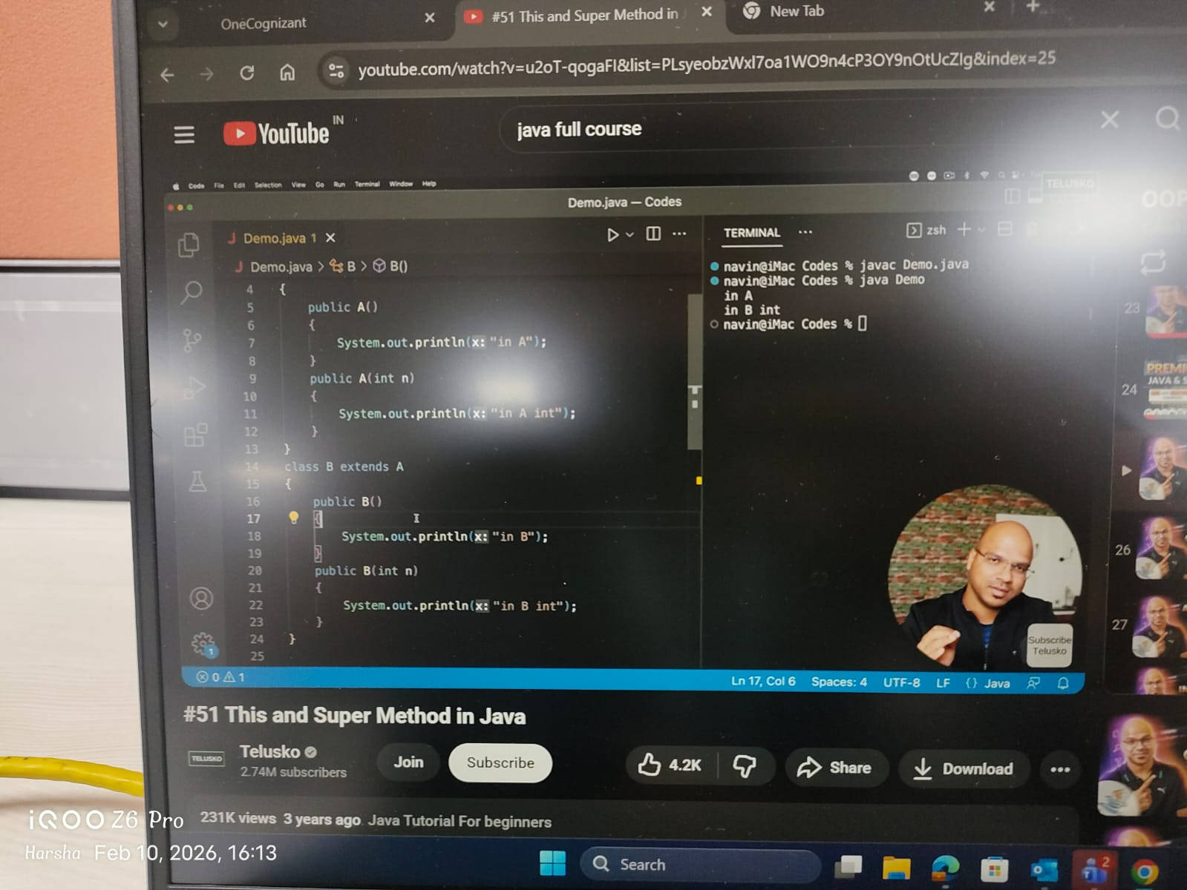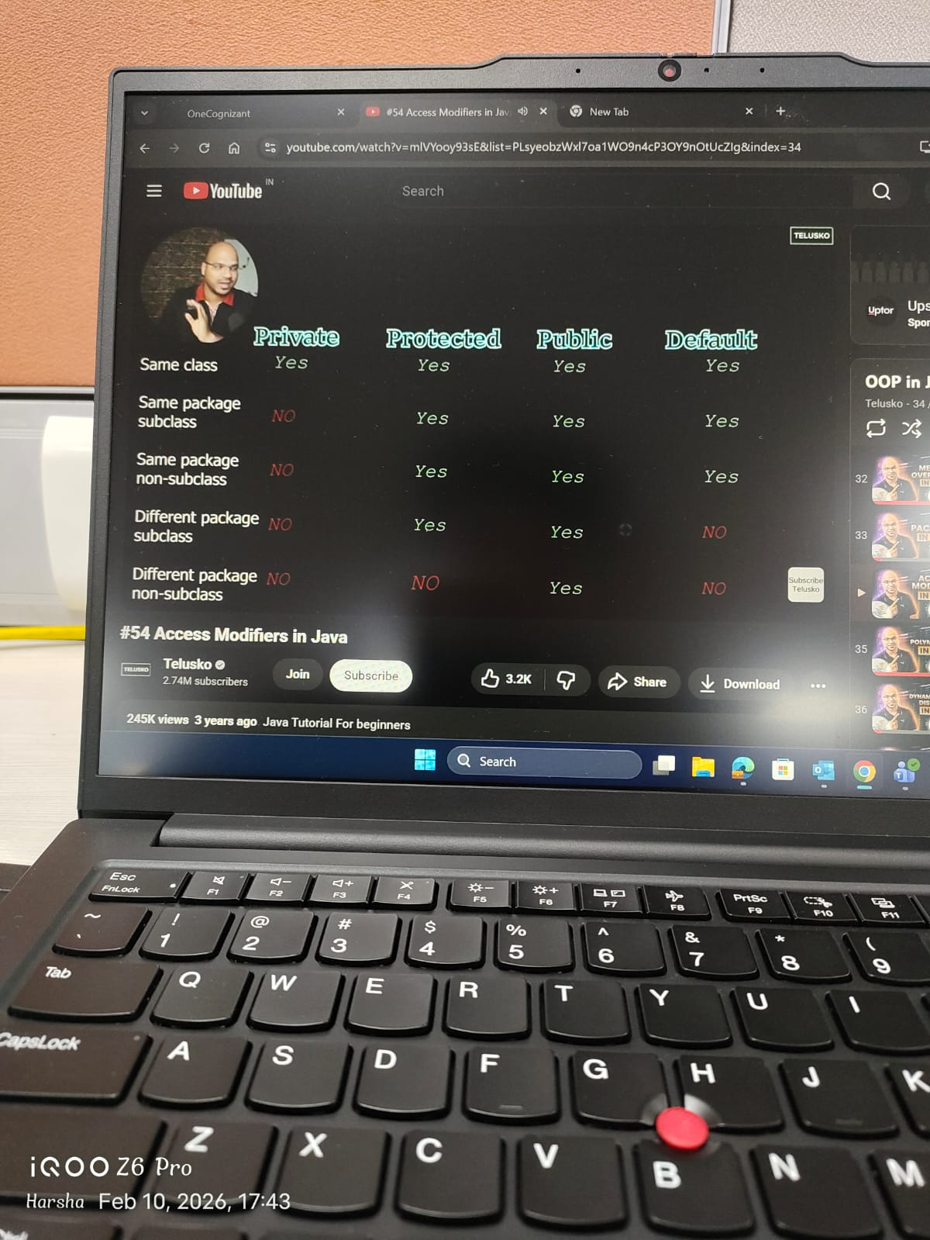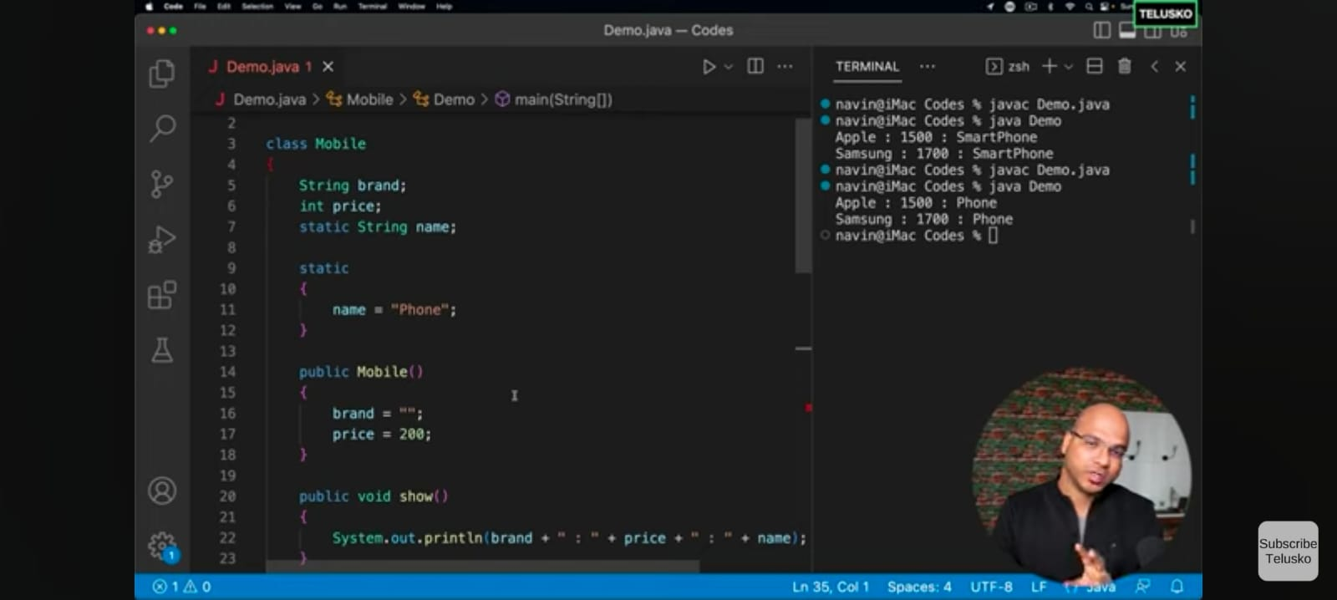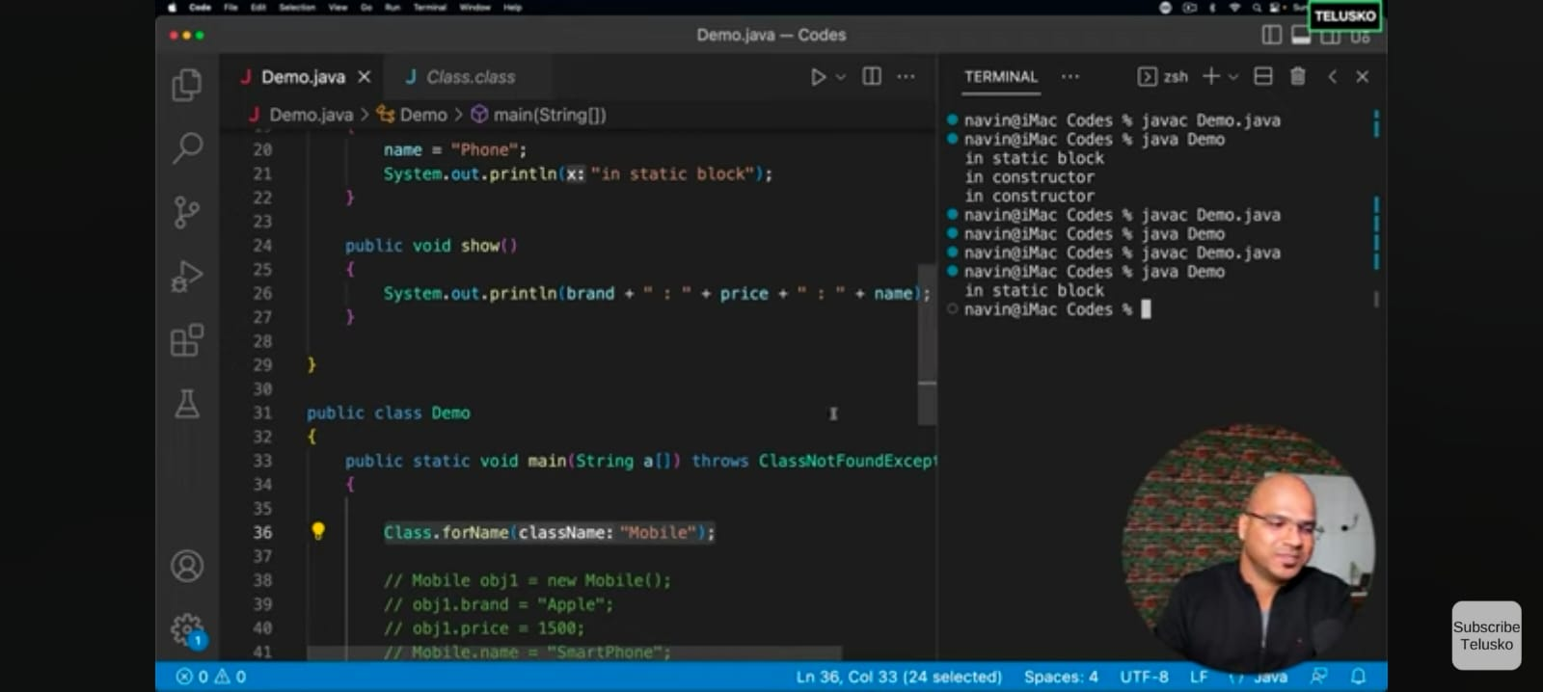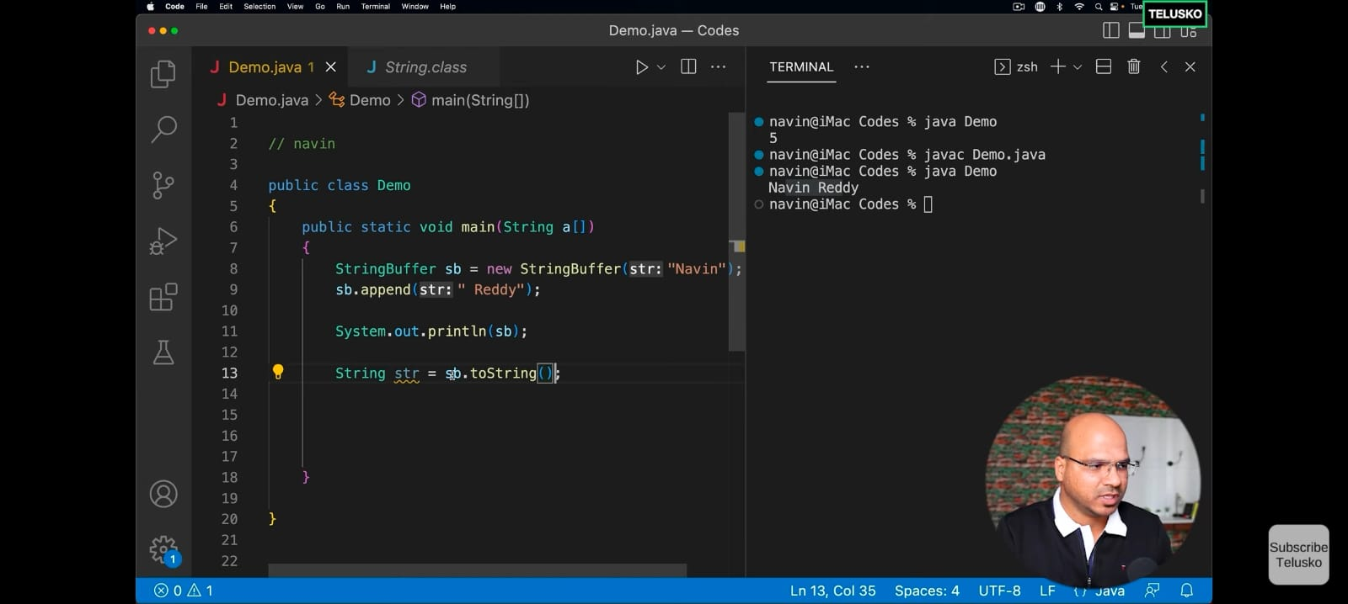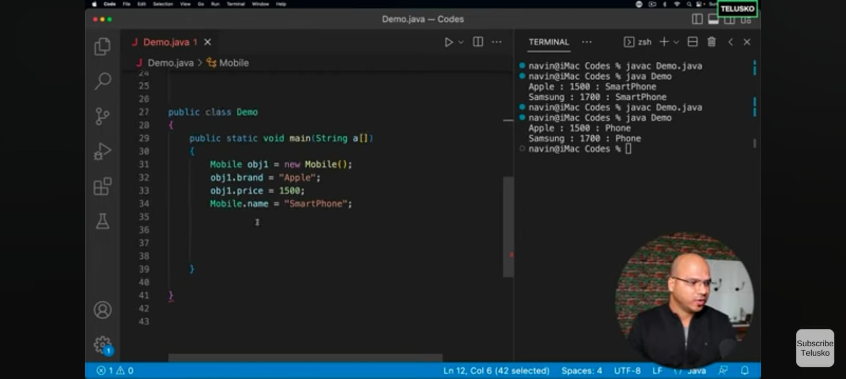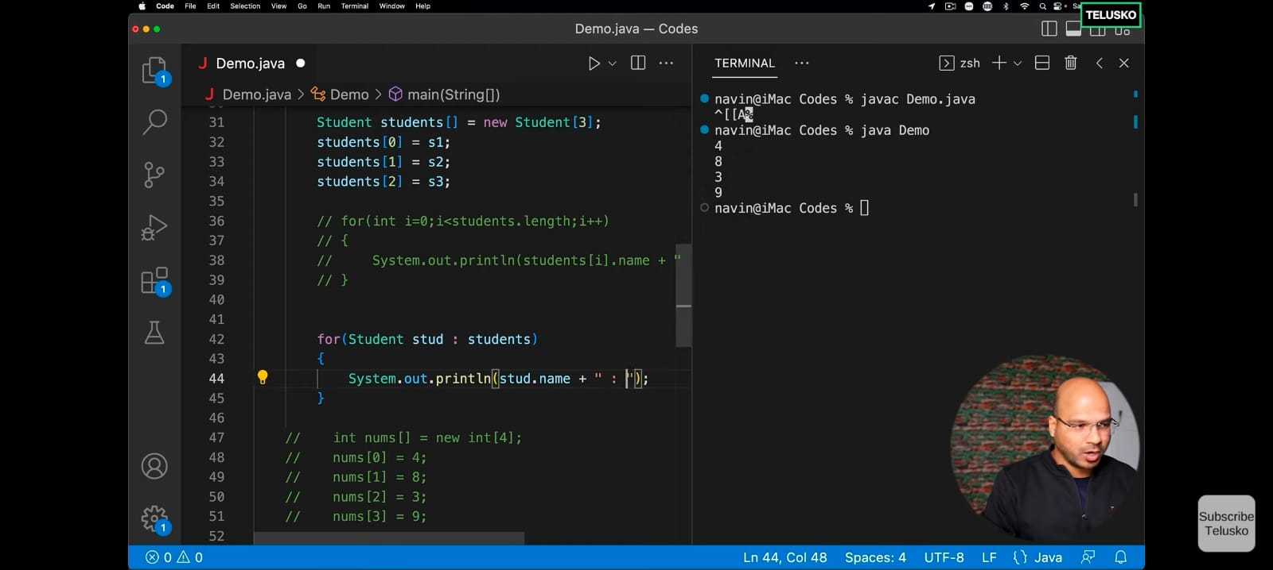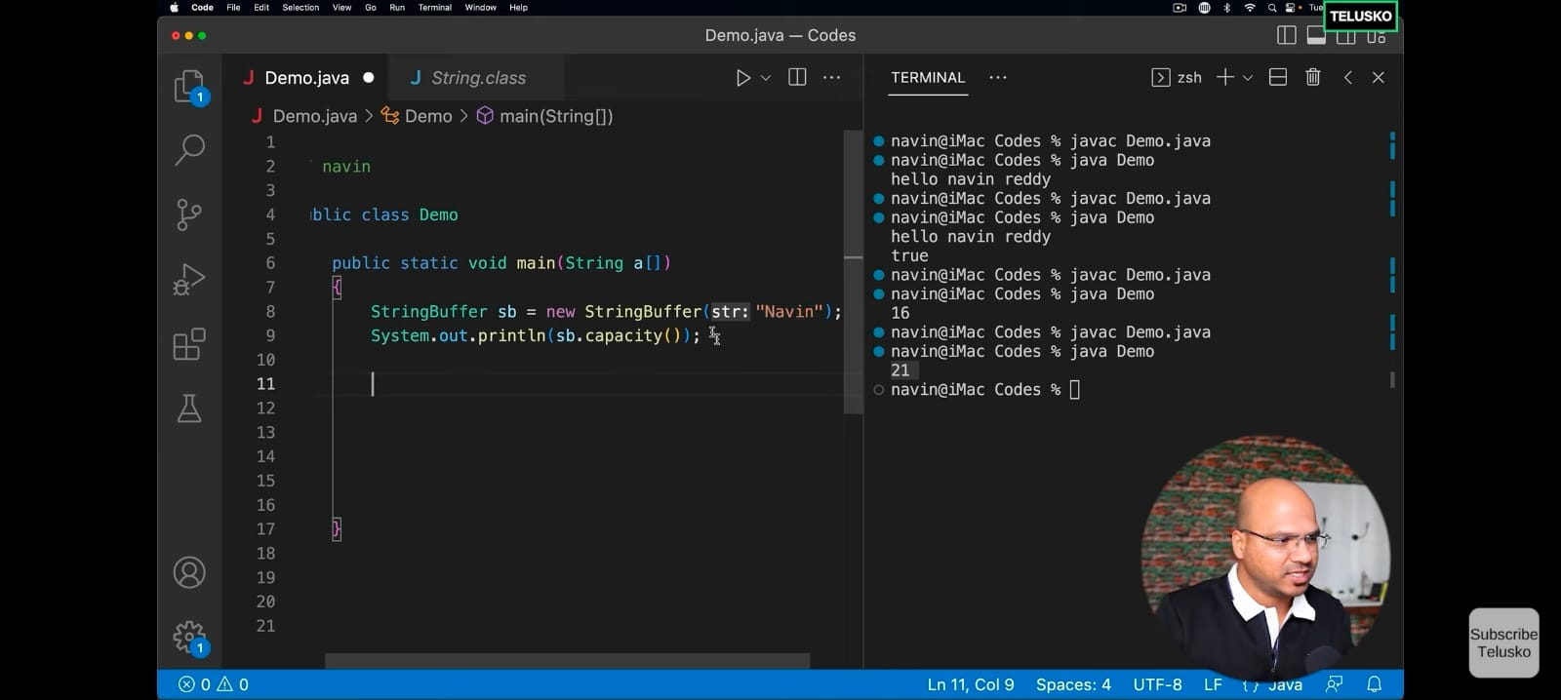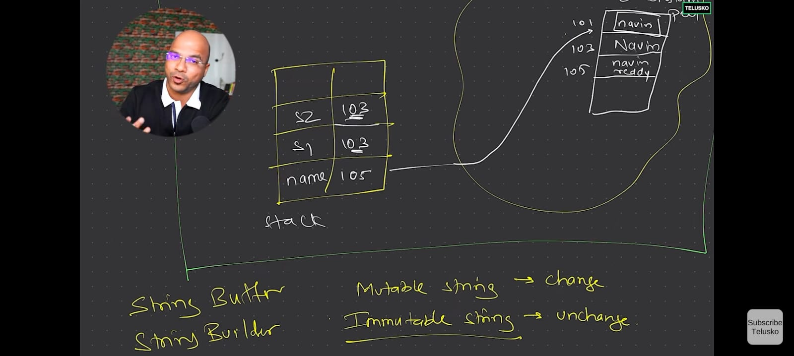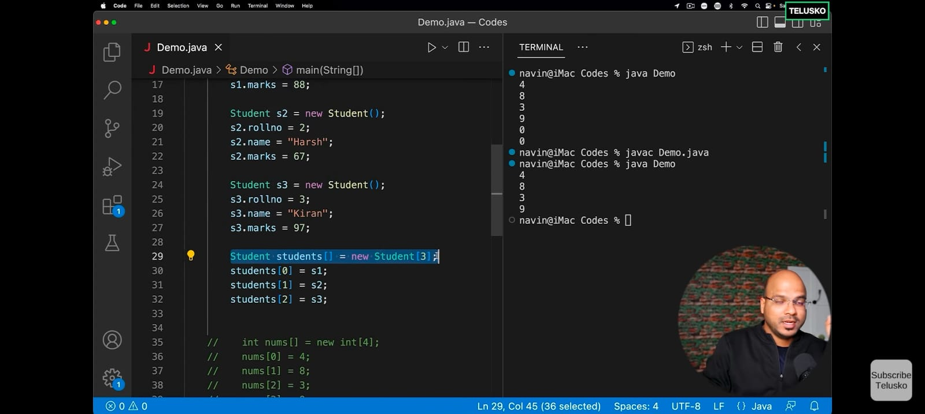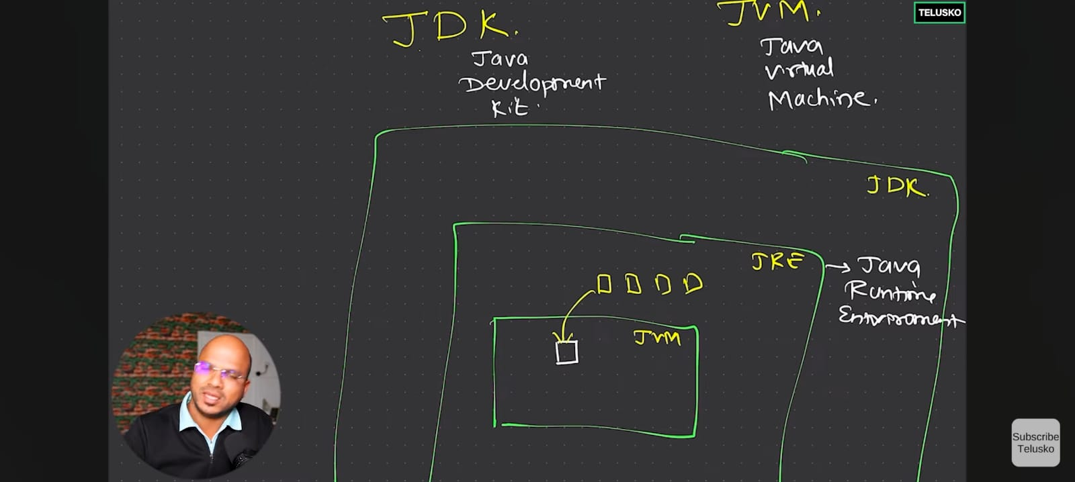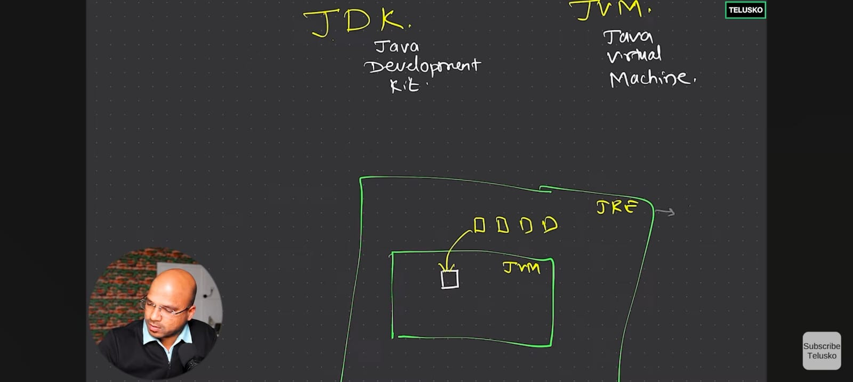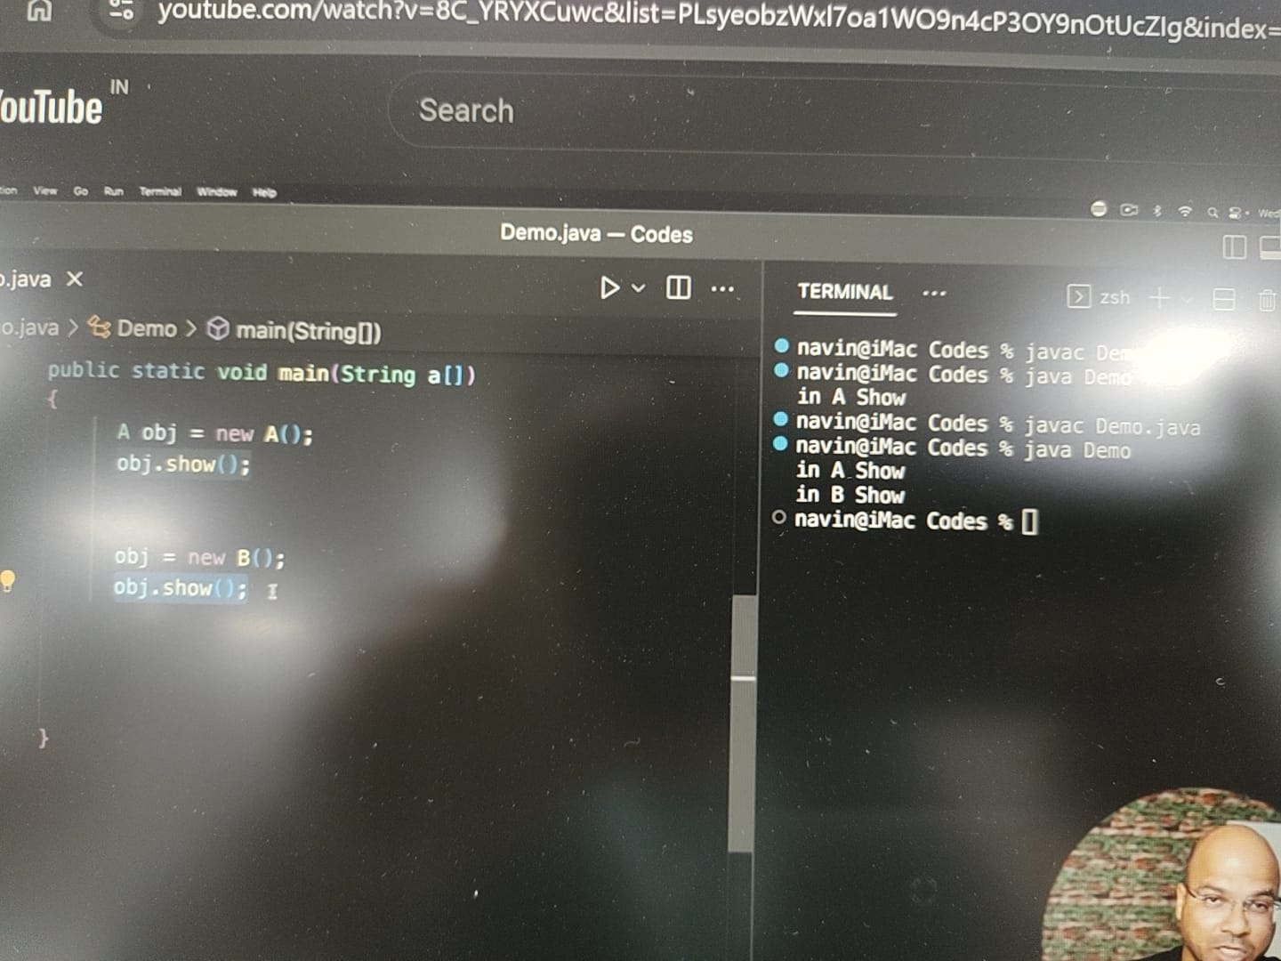

Final Variable cannot be changes
Final Class cannot be Inherited
Final Method cannot be overridden by other method in the child class

Encapsulation (Data Hiding)
Encapsulation is the process of wrapping data (variables) and code (methods) together as a single unit. We achieve this by making variables private and providing public Getters and Setters.
Why? It protects the internal state of an object from unauthorized modification and allows you to add validation logic.
Java
class UserAccount {
private String username;
private double balance; // Hidden from direct access

public UserAccount(String username, double initialBalance) {
this.username = username;
this.balance = initialBalance;
}

// Getter for Balance
public double getBalance() {
return balance;
}

// Setter with validation logic
public void deposit(double amount) {
if (amount > 0) {
this.balance += amount;
System.out.println("Deposited: " + amount);
} else {
System.out.println("Invalid deposit amount!");
}
}
}

public class EncapsulationMain {
public static void main(String[] args) {
UserAccount myAccount = new UserAccount("Harsha", 1000.0);

// myAccount.balance = -500; // COMPILATION ERROR: balance is private
myAccount.deposit(500.0);
System.out.println("Final Balance: " + myAccount.getBalance());
}
}

2. Inheritance (is-a relationship)
Inheritance allows one class to acquire the properties and behaviors of another class. In Java, we use the extends keyword.
Why? It promotes code reusability. Instead of writing the same logic for different types of "Employees," you write common logic in a parent class and specific logic in child classes.
Java
class Employee {
String name;
int id;

void login() {
System.out.println("Employee " + name + " logged into the system.");
}
}

class Developer extends Employee {
String techStack;

void writeCode() {
System.out.println(name + " is writing code in " + techStack);
}
}

public class InheritanceMain {
public static void main(String[] args) {
Developer dev = new Developer();
dev.name = "Harsha"; // Inherited from Employee
dev.id = 1922; // Inherited from Employee
dev.techStack = "Java & Angular";

dev.login(); // Inherited method
dev.writeCode(); // Own method
}
}

3. Polymorphism (Many Forms)
Polymorphism allows us to perform a single action in different ways.
A. Compile-time Polymorphism (Method Overloading)
This occurs when multiple methods have the same name but different parameters (number or type). It is resolved by the compiler.
B. Runtime Polymorphism (Method Overriding)
This occurs when a child class provides a specific implementation for a method already defined in its parent. It is resolved by the JVM at execution time.
Java
class PaymentProcessor {
// Overloading: Same name, different parameters
void pay(double amount) {
System.out.println("Processing generic payment of: " + amount);
}

void pay(double amount, String coupon) {
System.out.println("Processing " + amount + " with coupon: " + coupon);
}

// This method will be overridden
void processTransaction() {
System.out.println("General transaction processing...");
}
}

class CreditCardPayment extends PaymentProcessor {
@Override
void processTransaction() {
System.out.println("Processing Credit Card transaction with encrypted security.");
}
}

public class PolymorphismMain {
public static void main(String[] args) {
PaymentProcessor pp = new CreditCardPayment(); // Upcasting

// Overloading call (Compile-time)
pp.pay(500.0, "SAVE50");

// Overriding call (Runtime)
// JVM calls the child version even though the reference type is parent
pp.processTransaction();
}
}

4. Abstraction (Hiding Complexity)
Abstraction is the concept of hiding internal implementation details and showing only the essential features to the user.
- Abstract Class: A class that cannot be instantiated and may contain abstract methods (methods without a body).
- Interface: A completely "abstract" blueprint that defines what a class must do, but not how it does it.
Java
interface NotificationService {
void send(String message); // Abstract by default
}

class EmailService implements NotificationService {
public void send(String message) {
System.out.println("Sending Email: " + message);
}
}

class SmsService implements NotificationService {
public void send(String message) {
System.out.println("Sending SMS: " + message);
}
}

public class AbstractionMain {
public static void main(String[] args) {
// You don't care HOW it sends, you just know it HAS a send method
NotificationService service;

service = new EmailService();
service.send("Your OTP is 1234");

service = new SmsService();
service.send("Your OTP is 1234");
}
}

Comparison Summary
Concept | Primary Focus | Keyword
Encapsulation | Security & Data Integrity | private, get/set
Inheritance | Code Reusability | extends
Polymorphism | Flexibility & "Many Forms" | @Override
Abstraction | Hiding Complexity | abstract, interface

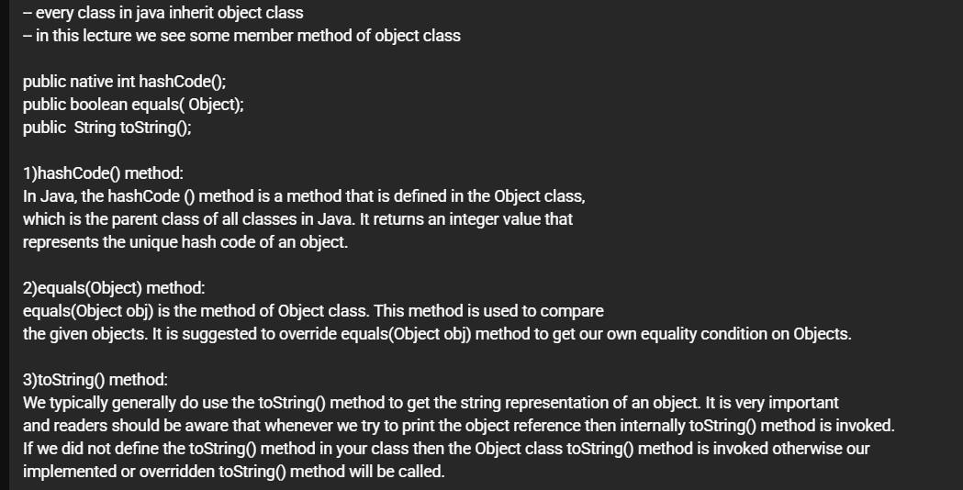

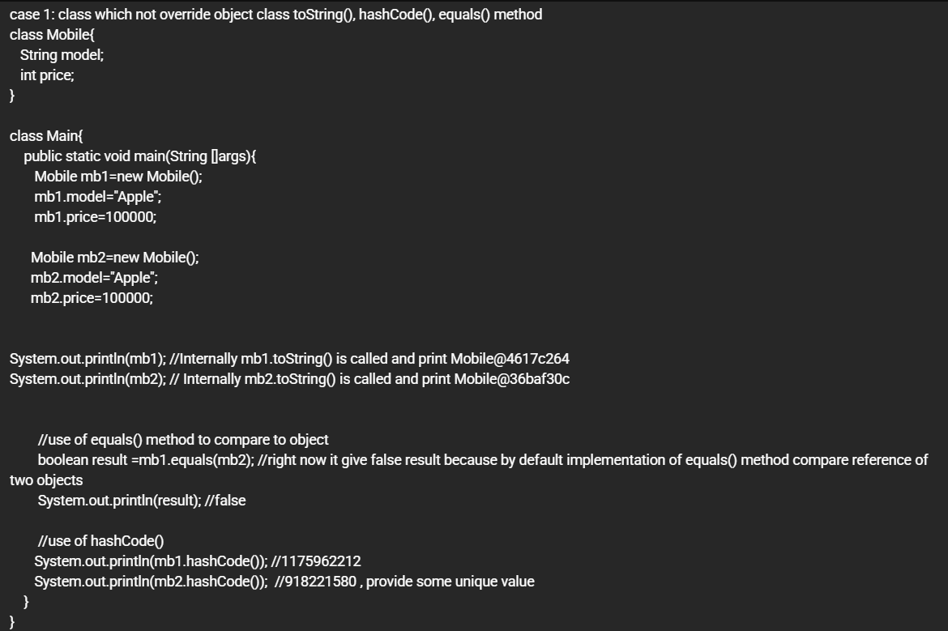

ABSTRACT
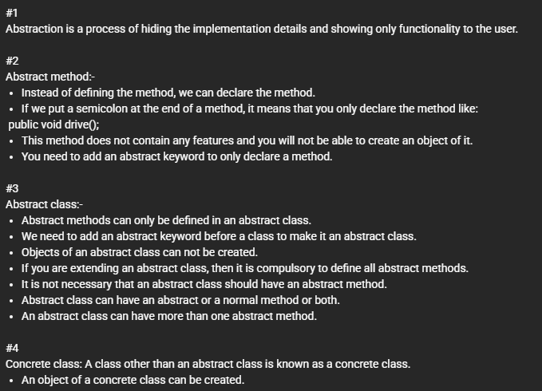
Inner Class
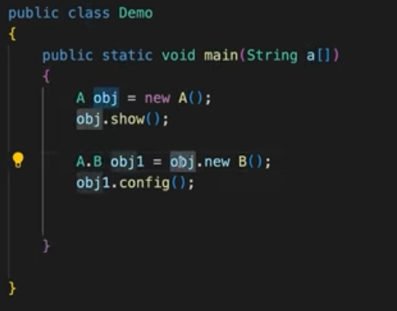
NEED FOR INTERFACE

/*
abstract class Computer
{
public abstract void code();
}

class Laptop extends Computer
{
public void code()
{
System.out.println("code, compile, run");
}

}

class Desktop extends Computer
{
public void code()
{
System.out.println("code, compile, faster");
}
}
class Developer
{
// public void devApp(Laptop lap)
public void devApp(Computer lap)
{
lap.code();
}
}
public class Demo {
public static void main(String[] args) {
// Laptop lap=new Laptop();
// Desktop desk=new Desktop();

Computer lap=new Laptop();
Computer desk=new Desktop();

Developer navin=new Developer();
navin.devApp(lap);

}
}*/
interface Computer
{
void code();
}

class Laptop implements Computer
{
public void code()
{
System.out.println("code, compile, run");
}

}

class Desktop implements Computer
{
public void code()
{
System.out.println("code, compile, faster");
}
}
class Developer
{
// public void devApp(Laptop lap)
public void devApp(Computer lap)
{
lap.code();
}
}

public class Demo {
public static void main(String[] args) {
// Laptop lap=new Laptop();
// Desktop desk=new Desktop();

Computer lap=new Laptop();
Computer desk=new Desktop();

Developer navin=new Developer();
navin.devApp(lap);

}
}
WHAT IS INTERFACE

interface A
{
// public abstract void show();
// public abstract void config();
int age=44; // final and static
String area="Mumbai";

void show();
void config();
}

class B implements A
{
public void show()
{
System.out.println("in show");
}
public void config()
{
System.out.println("in cofing");
}
}

public class Demo {
public static void main(String[] args) {

A obj;
obj=new B();

obj.show();
obj.config();

// A.area="Hyderabad";

System.out.println(A.area);

}
}
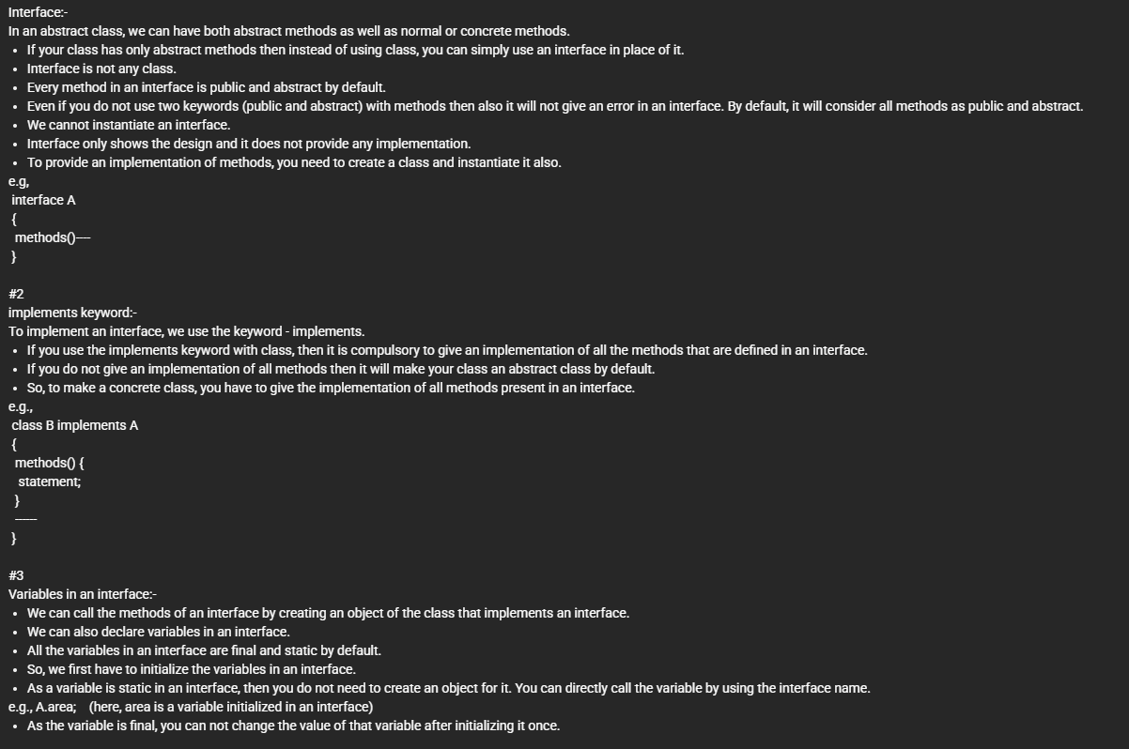

Method Overriding
Method Overriding occurs when a subclass provides a specific implementation for a method that is already defined in its superclass.
- Rule: The method must have the same name, return type, and parameters.
- Annotation: We use @Override to tell the compiler to check if we are actually overriding a method (prevents typos).

2. The super Keyword
The super keyword is a reference variable used to refer to immediate parent class objects.
- To call parent methods: Useful if the child has overridden them but still needs the original logic.
- To call parent constructors: Must be the first statement in the child constructor.
- To access parent variables: If the child has a variable with the same name (shadowing).

3. The final Keyword
The final keyword is used to restrict the user in three ways:
- Final Variable: Creates a constant (value cannot be changed).
- Final Method: Prevents Method Overriding.
- Final Class: Prevents Inheritance (the class cannot be extended).

4. The Object Class
In Java, every class implicitly inherits from the java.lang.Object class. It is the root of the entire hierarchy. Common methods you will override in professional projects:
- toString(): Returns a string representation of the object (great for logging).
- equals(Object obj): Compares two objects for equality (instead of memory address).
- hashCode(): Returns a unique integer for the object (used in HashMaps).

5. The instanceof Operator
This is a comparison operator used to check if an object is an instance of a specific class or interface. It returns a boolean.

Comprehensive Example
This example demonstrates a Payment System where we use final to secure business rules and super to reuse logic.
Java
// Root Class (All classes inherit from Object)
class BaseTransaction {
@Override
public String toString() {
return "Base Transaction Record";
}
}

class Payment extends BaseTransaction {
double amount;

Payment(double amount) {
this.amount = amount;
}

// A final method cannot be changed by any child class
final void showCurrency() {
System.out.println("Currency: USD");
}

void process() {
System.out.println("Processing payment of $" + amount);
}
}

class CreditCardPayment extends Payment {
double serviceFee = 2.50;

CreditCardPayment(double amount) {
super(amount); // Calling parent constructor
}

@Override
void process() {
super.process(); // Executing parent's logic first
System.out.println("Adding Credit Card fee: $" + serviceFee);
System.out.println("Total: $" + (amount + serviceFee));
}

void validateCard() {
System.out.println("Card Validated.");
}
}

public class MainSystem {
public static void main(String[] args) {
Payment p = new CreditCardPayment(100.0);

// 1. Method Overriding in action
p.process();

// 2. final usage
p.showCurrency();

// 3. instanceof operator
if (p instanceof CreditCardPayment) {
// Downcasting to access child-specific methods
CreditCardPayment ccp = (CreditCardPayment) p;
ccp.validateCard();
}

// 4. Object class method
System.out.println(p.toString());
}
}

Key Takeaways for an Intern
- super() vs this(): super() calls the parent constructor; this() calls another constructor in the same class. Both must be the first line.
- Why use final? Use it for security. For example, in a banking app, the calculateInterest() method might be final so no one can accidentally override it with a malicious version.
- instanceof in APIs: When your Java backend receives a generic "Object" from a JSON request, you often use instanceof to verify if it’s the correct Data Transfer Object (DTO) before processing.
Abstract Classes
An abstract class is a class that cannot be instantiated (you can't use new on it). it acts as a partial blueprint.
- Why use it? When you have a group of classes that share some common code (concrete methods) but also have some unique behavior (abstract methods).
- Key Feature: It can have state (instance variables) and constructors.
Example: Base Repository
In a backend, you might have many services that need to "log" actions, but "save" data differently.
Java
// File: BaseService.java
abstract class BaseService {
String serviceName;

BaseService(String name) {
this.serviceName = name;
}

// Concrete method: All services share this logic
void logAction(String action) {
System.out.println("[" + serviceName + "] Logging: " + action);
}

// Abstract method: Each service MUST implement its own save logic
abstract void saveData(String data);
}

// File: UserService.java
class UserService extends BaseService {
UserService() {
super("User-Service");
}

@Override
void saveData(String data) {
System.out.println("Saving user info to MySQL: " + data);
}
}

// File: Main.java
public class Main {
public static void main(String[] args) {
BaseService service = new UserService();
service.logAction("Create User");
service.saveData("Harsha Phani Teja");
}
}

2. Interfaces
An interface is a contract. Any class that "implements" an interface promises to provide functionality for all its methods.
- Why use it? To achieve total abstraction and decouple your code. In Angular, you define Interfaces for your JSON data; in Java, you define Interfaces for your API services.
- Key Feature: A class can implement multiple interfaces, which isn't possible with classes.
Java
// File: MessagingProvider.java
interface MessagingProvider {
// All methods are public abstract by default
void sendMessage(String msg);
}

// File: WhatsAppProvider.java
class WhatsAppProvider implements MessagingProvider {
public void sendMessage(String msg) {
System.out.println("Sending WhatsApp: " + msg);
}
}

// File: Main.java
public class Main {
public static void main(String[] args) {
MessagingProvider provider = new WhatsAppProvider();
provider.sendMessage("Hello from Java Backend!");
}
}

3. Multiple Inheritance via Interfaces
Java doesn't allow a class to extend two classes (to avoid the "Diamond Problem"). However, a class can implement multiple interfaces.
Java
interface Camera { void takePhoto(); }
interface Phone { void makeCall(); }

class SmartDevice implements Camera, Phone {
public void takePhoto() { System.out.println("Capturing..."); }
public void makeCall() { System.out.println("Calling..."); }
}

4. Default & Static Methods (Java 8+)
Before Java 8, interfaces couldn't have code. Now they can.
- Default methods: Allow you to add new features to interfaces without breaking existing classes that implement them.
- Static methods: Utility methods that belong to the interface.
Java
interface Vehicle {
void start();

// Default method: Classes don't HAVE to override this
default void honk() {
System.out.println("Beep Beep!");
}

// Static method: Called using Vehicle.checkFuel()
static void checkFuel() {
System.out.println("Fuel check complete.");
}
}

5. Functional Interfaces
A Functional Interface is an interface that has exactly one abstract method. They are the foundation of Lambda Expressions.
Java
@FunctionalInterface
interface Authenticator {
boolean login(String username, String password);
}

// File: Main.java
public class Main {
public static void main(String[] args) {
// Using a Lambda instead of a whole class!
Authenticator auth = (u, p) -> u.equals("admin") && p.equals("123");

System.out.println("Auth Success: " + auth.login("admin", "123"));
}
}

6. Marker Interfaces
A Marker Interface is an interface with no methods or variables. It provides "metadata" to the JVM.
- Examples: Serializable, Cloneable, Remote.
- Usage: It tells the JVM: "This object is allowed to be saved to a file" (Serializable).

Summary: Abstract Class vs. Interface
Feature | Abstract Class | Interface
Methods | Can have abstract & concrete. | Mostly abstract (until Java 8).
Variables | Can have final, non-final, static, non-static. | Only public static final (constants).
Inheritance | A class can extends only one. | A class can implements many.
Constructor | Has constructors. | No constructors.

1. The Immutable Concept & String Pool
In Java, String objects are immutable, meaning once created, their value cannot be changed. If you try to modify a String, Java actually creates a brand-new String object in memory.
The String Constant Pool (SCP)
To save memory, Java uses a special area in the Heap called the String Pool. When you create a string literal, Java checks the pool first. If the string exists, it reuses the reference.
Java
public class StringPoolDemo {
public static void main(String[] args) {
String s1 = "Java"; // Created in Pool
String s2 = "Java"; // Points to the same object as s1
String s3 = new String("Java"); // Created in Heap (outside pool)

System.out.println(s1 == s2); // true (Same reference)
System.out.println(s1 == s3); // false (Different memory locations)
System.out.println(s1.equals(s3)); // true (Same content)
}
}

2. String vs. StringBuffer vs. StringBuilder
Since Strings are immutable, concatenating strings in a loop (e.g., s = s + "next") is very slow because it creates many temporary objects. To fix this, we use "mutable" classes.
Feature | String | StringBuffer | StringBuilder
Mutability | Immutable (Fixed) | Mutable (Changeable) | Mutable (Changeable)
Thread-Safe | Yes | Yes (Synchronized) | No
Speed | Slow for modifications | Medium | Fastest
Use Case: Use StringBuilder for high-performance string manipulation (like building a long SQL query) unless you are working with multiple threads.
Java
public class MutableDemo {
public static void main(String[] args) {
// Using StringBuilder for efficiency
StringBuilder sb = new StringBuilder("Hello");
sb.append(" Harsha");
sb.insert(5, ",");
sb.reverse();

System.out.println("Modified String: " + sb.toString());
}
}

3. Essential String Methods
These are the "bread and butter" methods you will use to clean and process data coming from your Angular forms.
Java
public class MethodDemo {
public static void main(String[] args) {
String data = " Full Stack Developer ";

System.out.println("Length: " + data.length());
System.out.println("Trimmed: '" + data.trim() + "'"); // Removes whitespace
System.out.println("Upper: " + data.toUpperCase());
System.out.println("Substring: " + data.substring(2, 6)); // "Full"
System.out.println("Contains 'Stack': " + data.contains("Stack"));
System.out.println("Replace: " + data.replace("Developer", "Engineer"));
}
}

4. StringTokenizer
This is a legacy class used to break a string into "tokens" based on a delimiter (like a comma or space). While split() is more common now, StringTokenizer is faster for very large strings.
Java
import java.util.StringTokenizer;

public class TokenDemo {
public static void main(String[] args) {
String csvData = "Java,Spring,Angular,MySQL";
StringTokenizer st = new StringTokenizer(csvData, ",");

while (st.hasMoreTokens()) {
System.out.println("Tech: " + st.nextToken());
}
}
}

5. Formatting Strings
When you want to build a string with variables (like an error message), String.format() or System.out.printf() is much cleaner than using many + signs.
Java
public class FormatDemo {
public static void main(String[] args) {
String name = "Harsha";
int tasks = 5;
double progress = 85.5;

// %s = String, %d = Integer, %.2f = Float/Double with 2 decimals
String message = String.format("Intern: %s, Tasks: %d, Completion: %.2f%%", name, tasks, progress);

System.out.println(message);
}
}
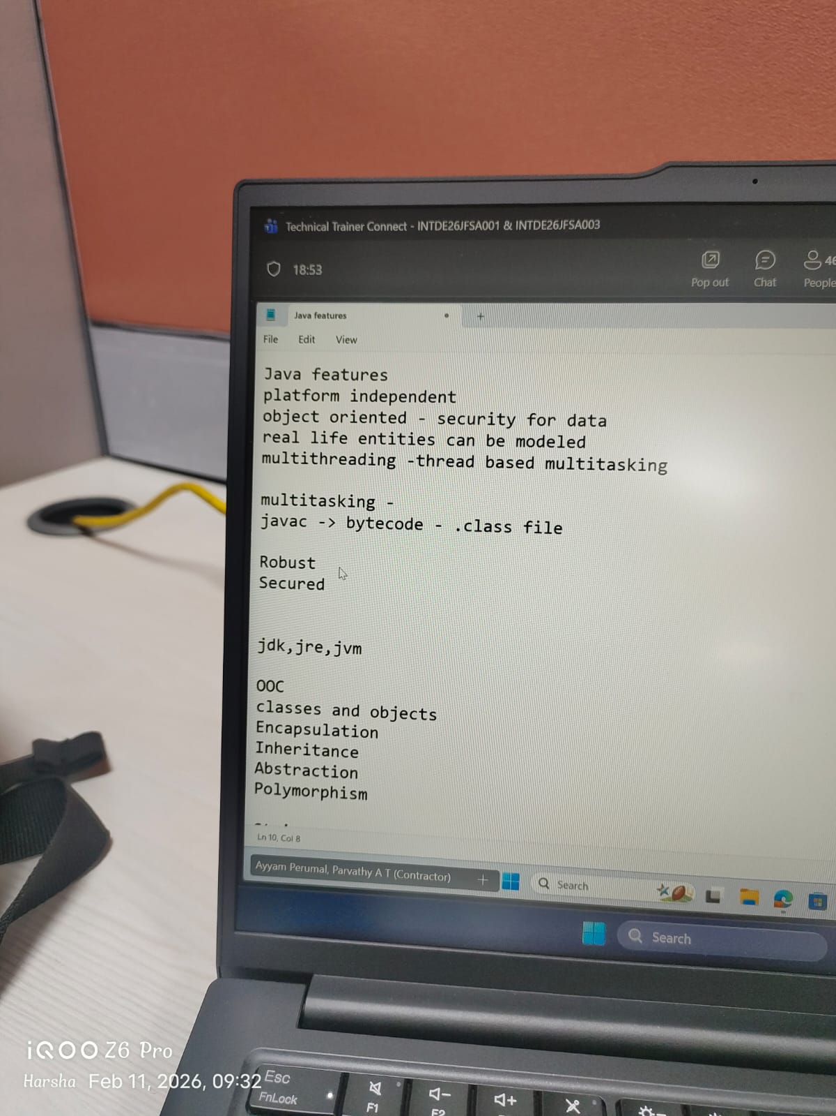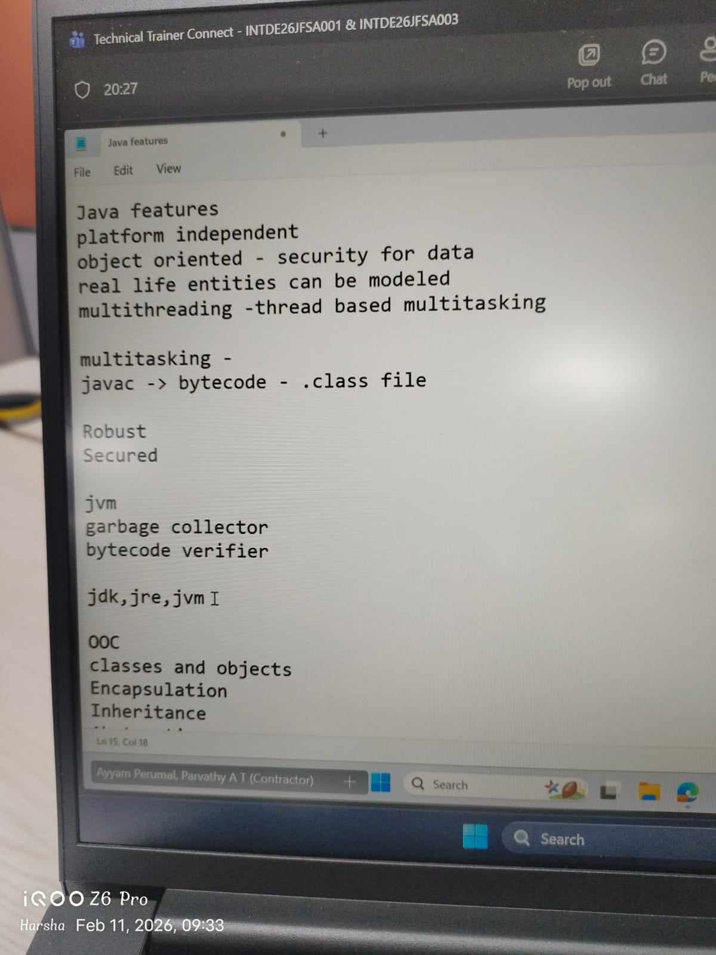
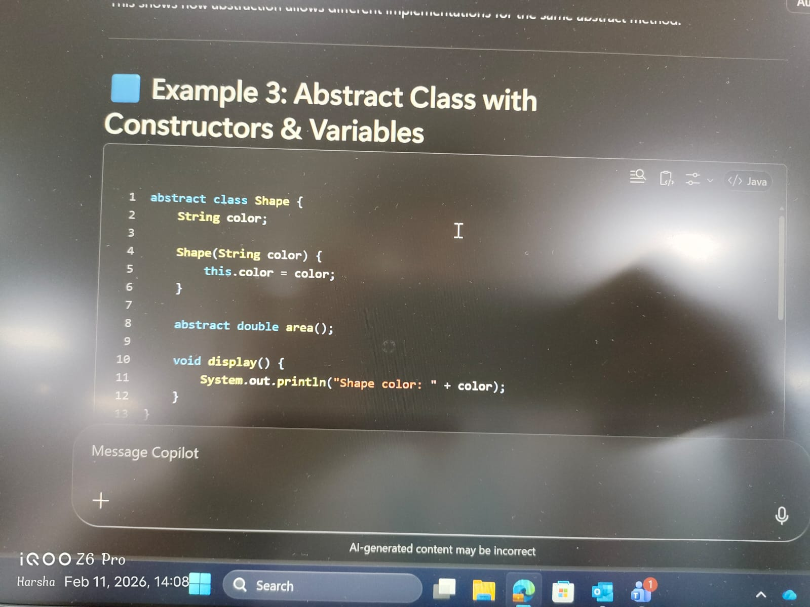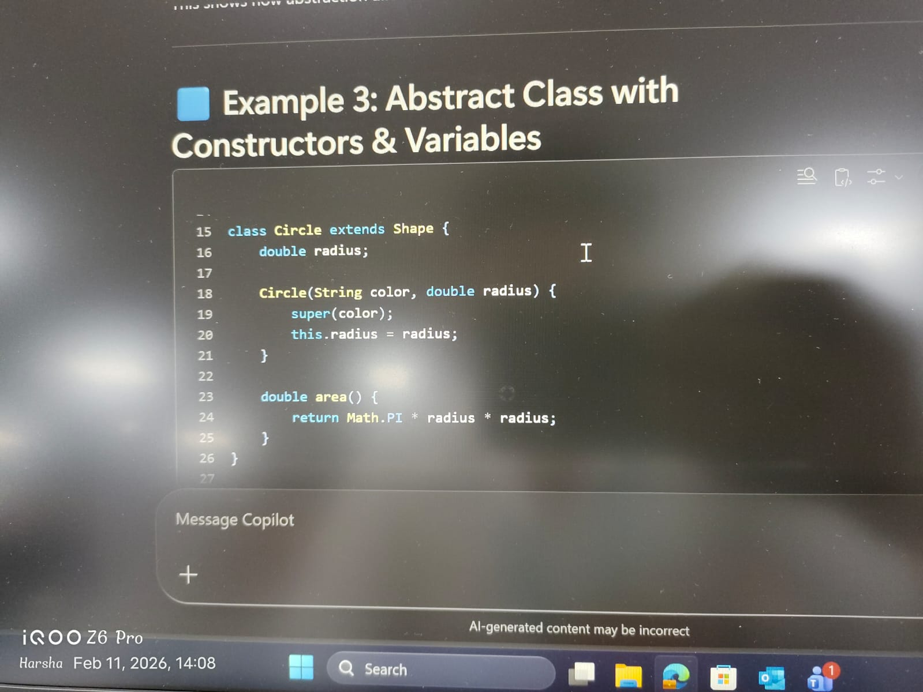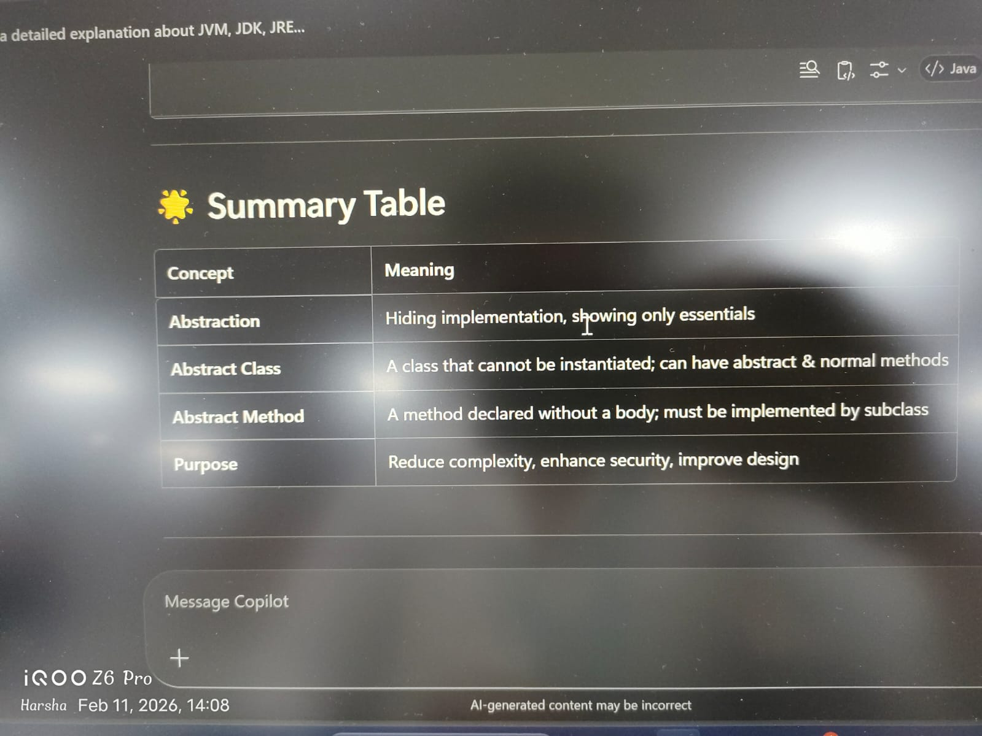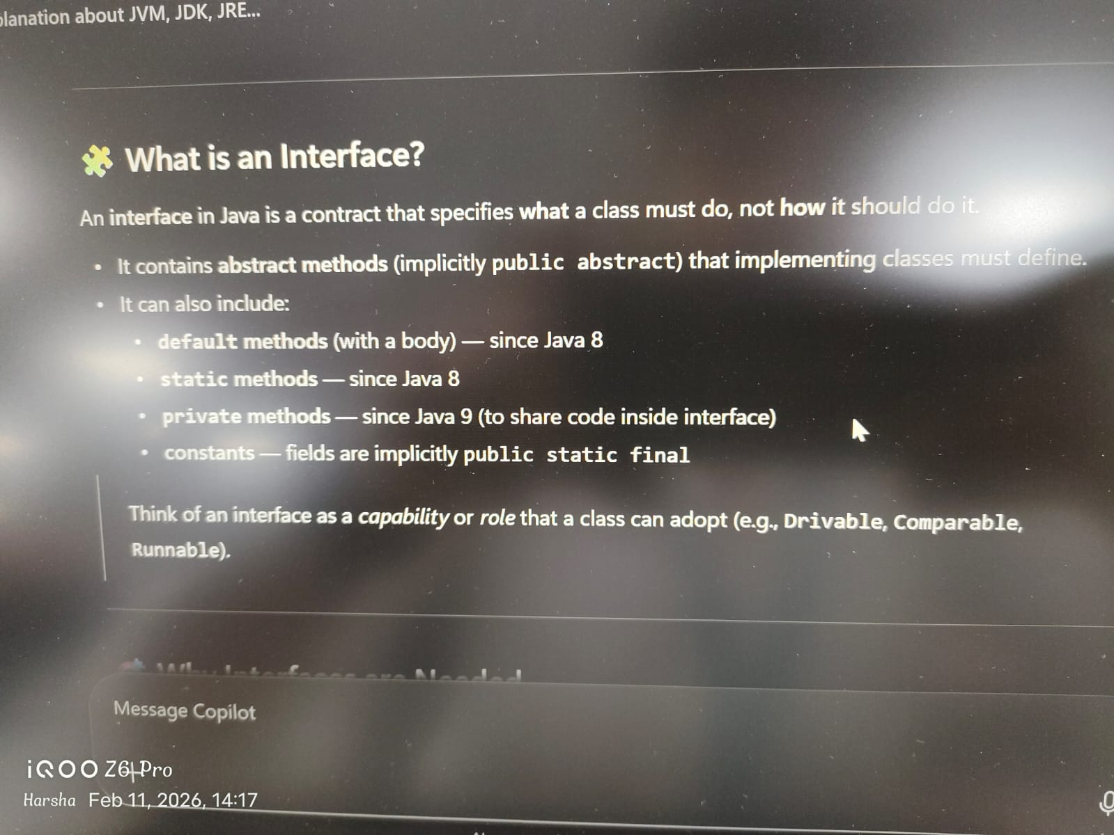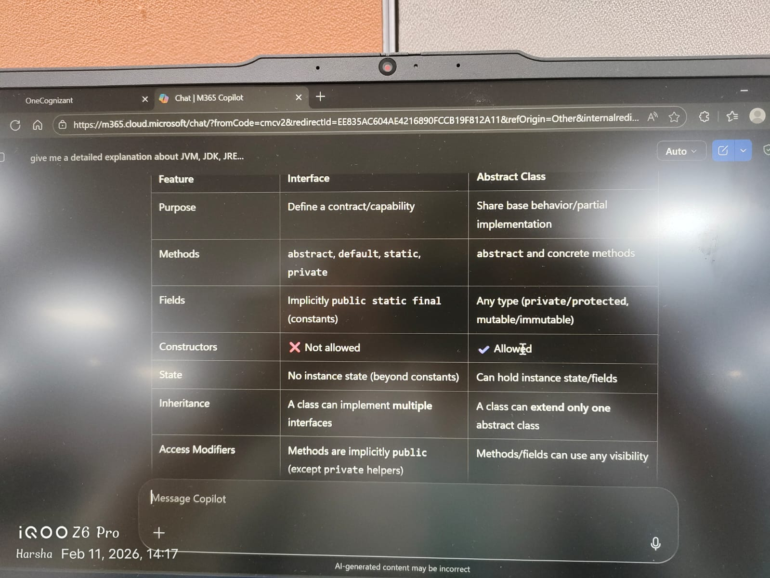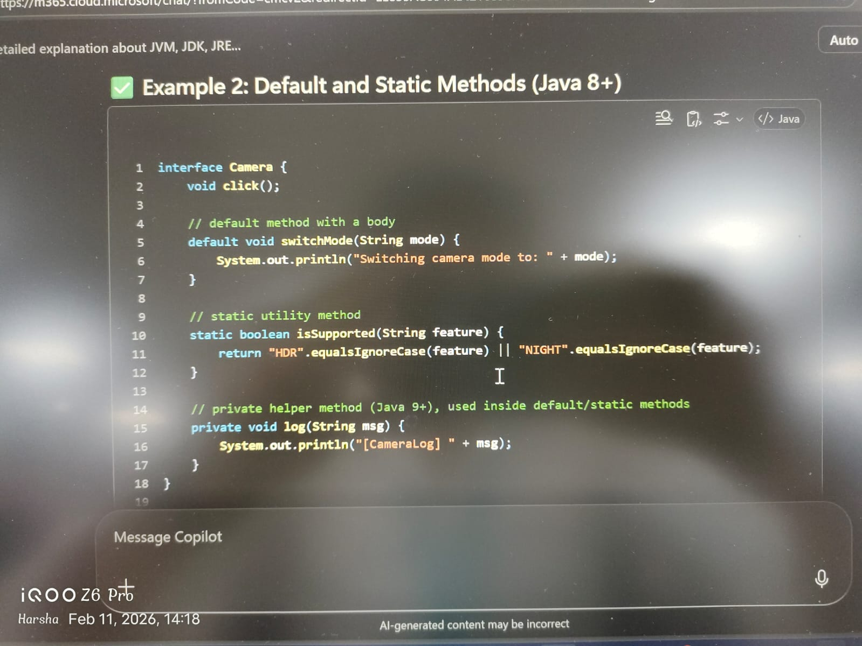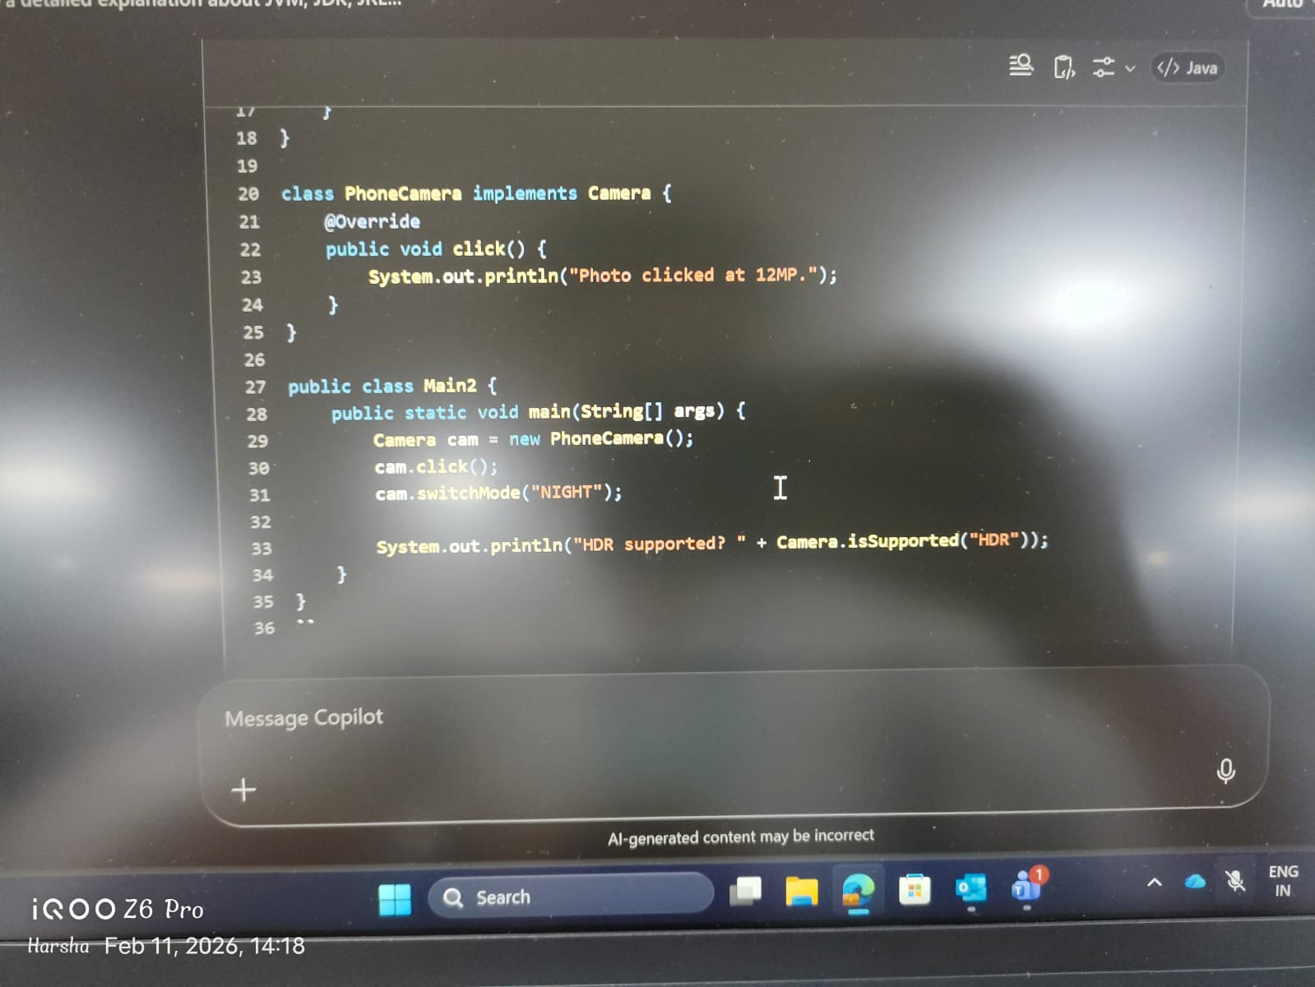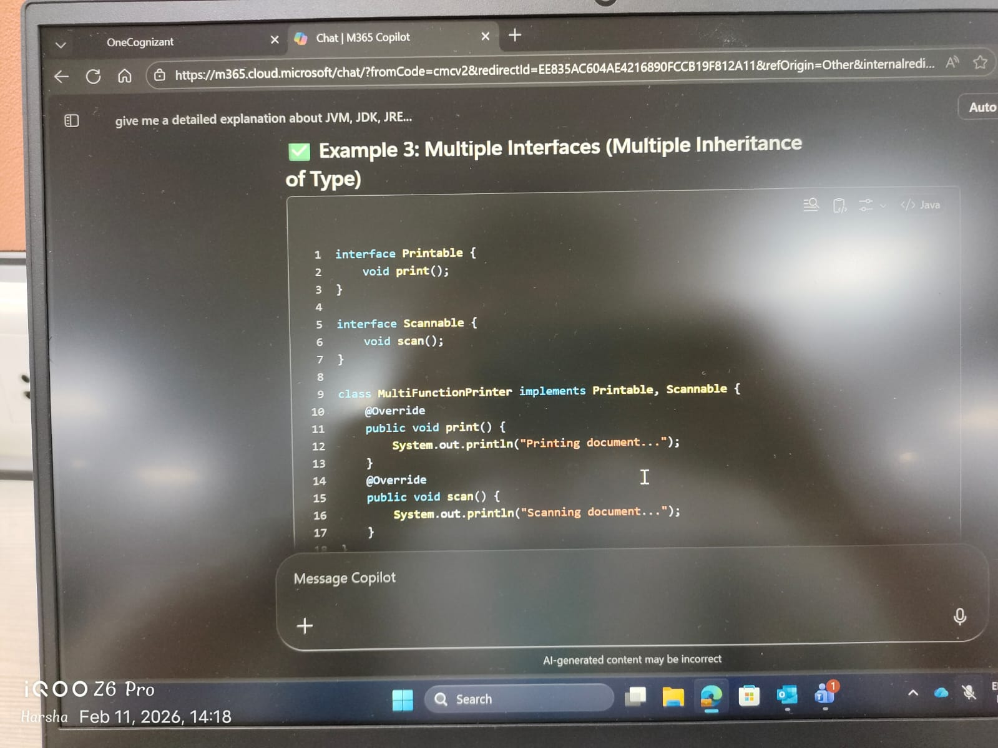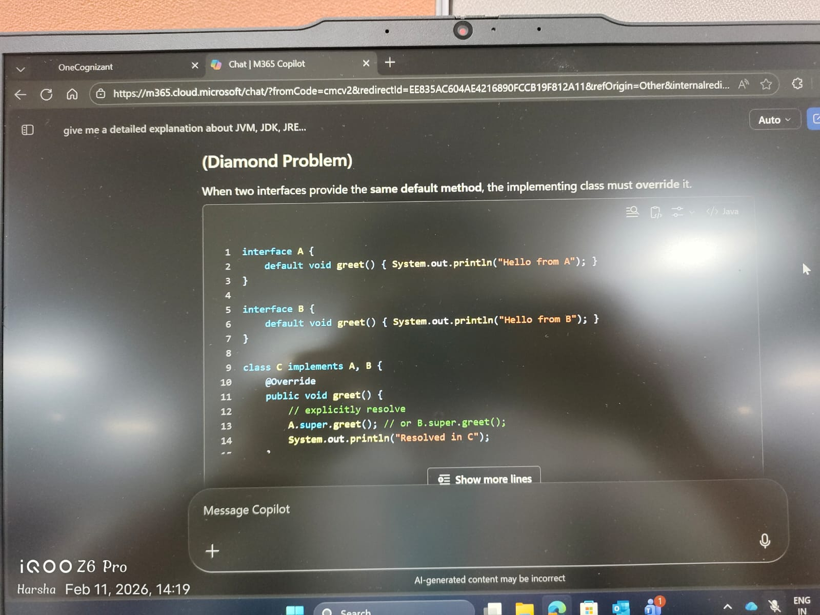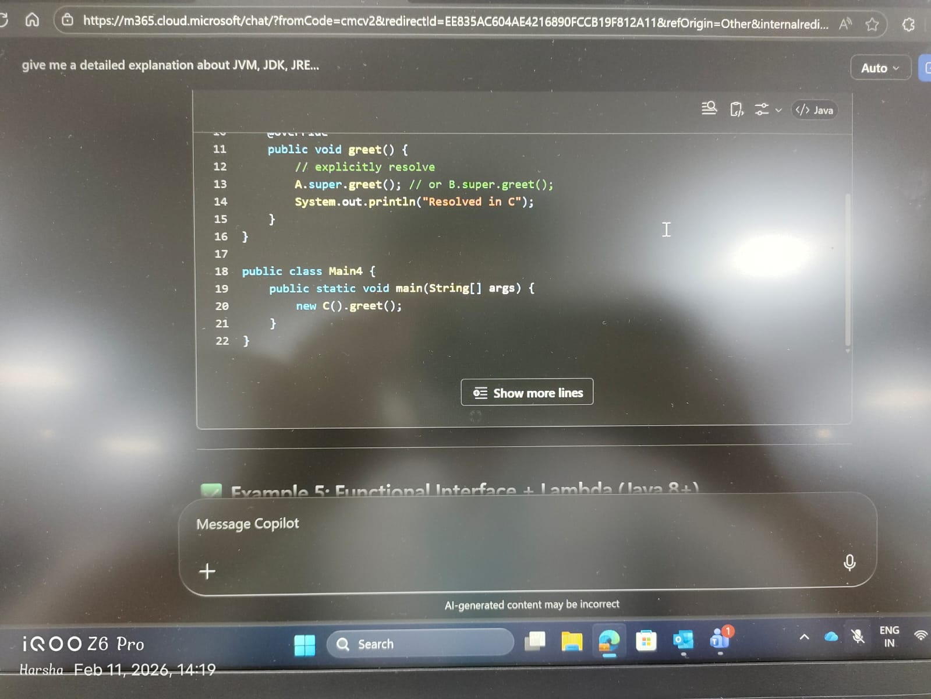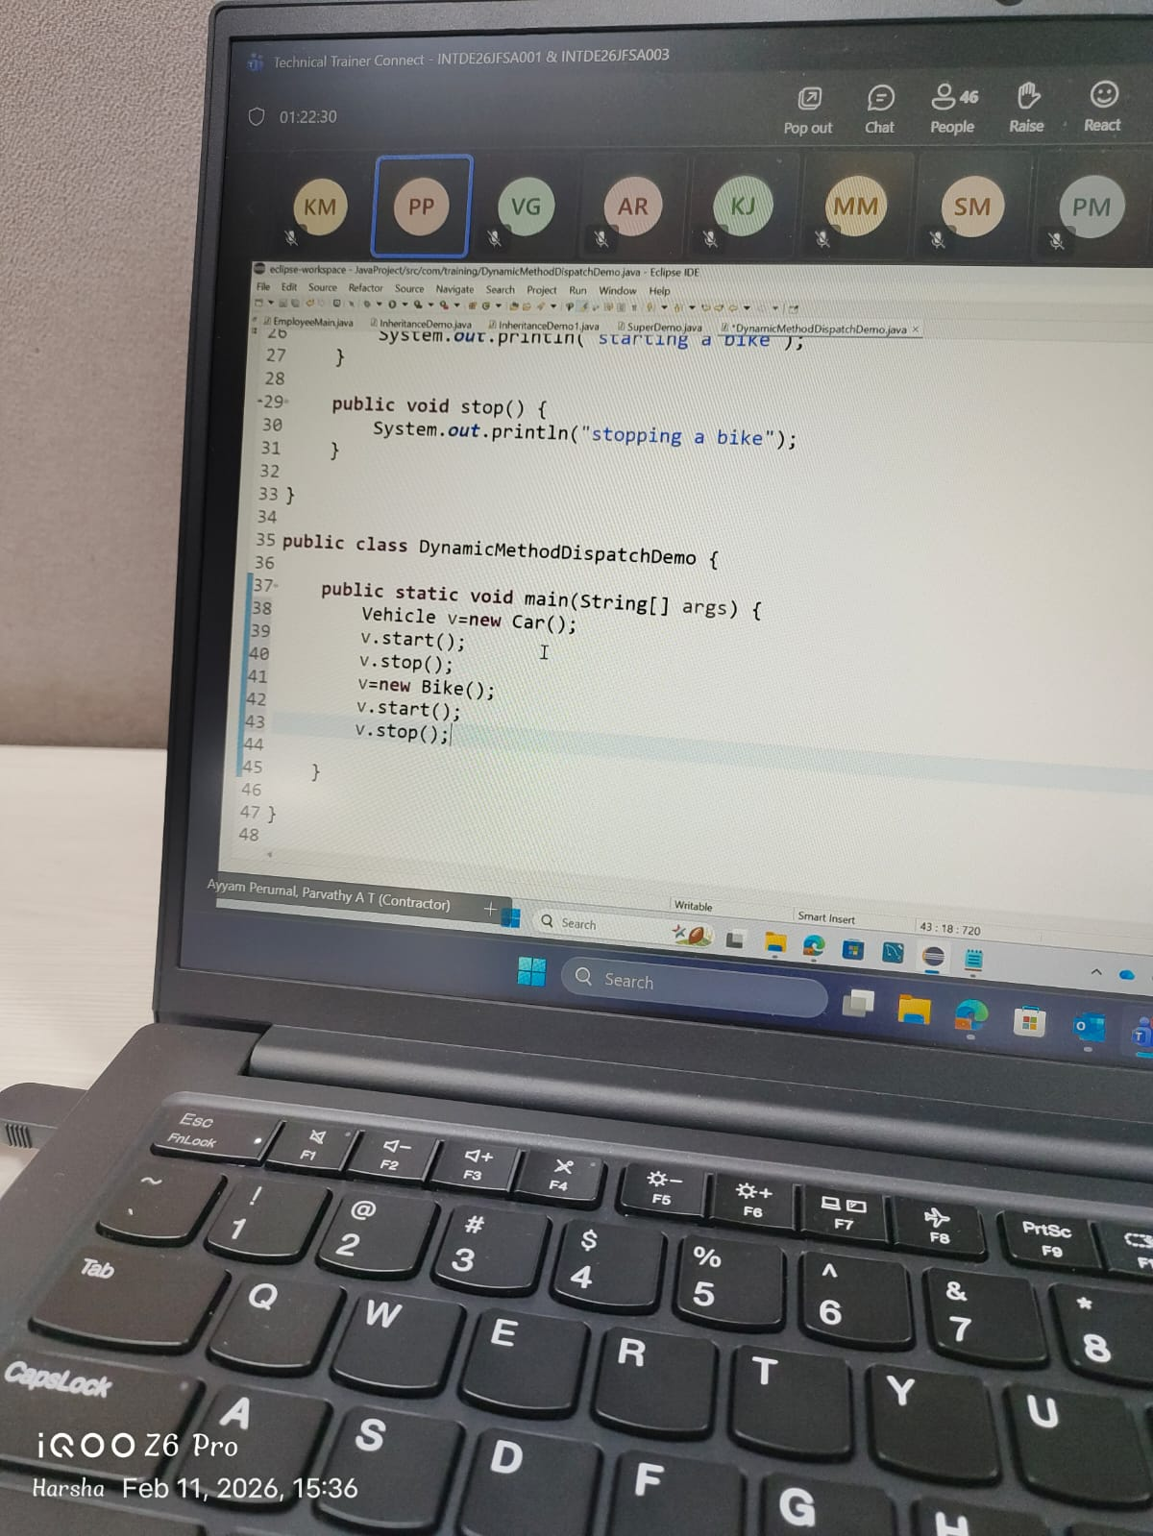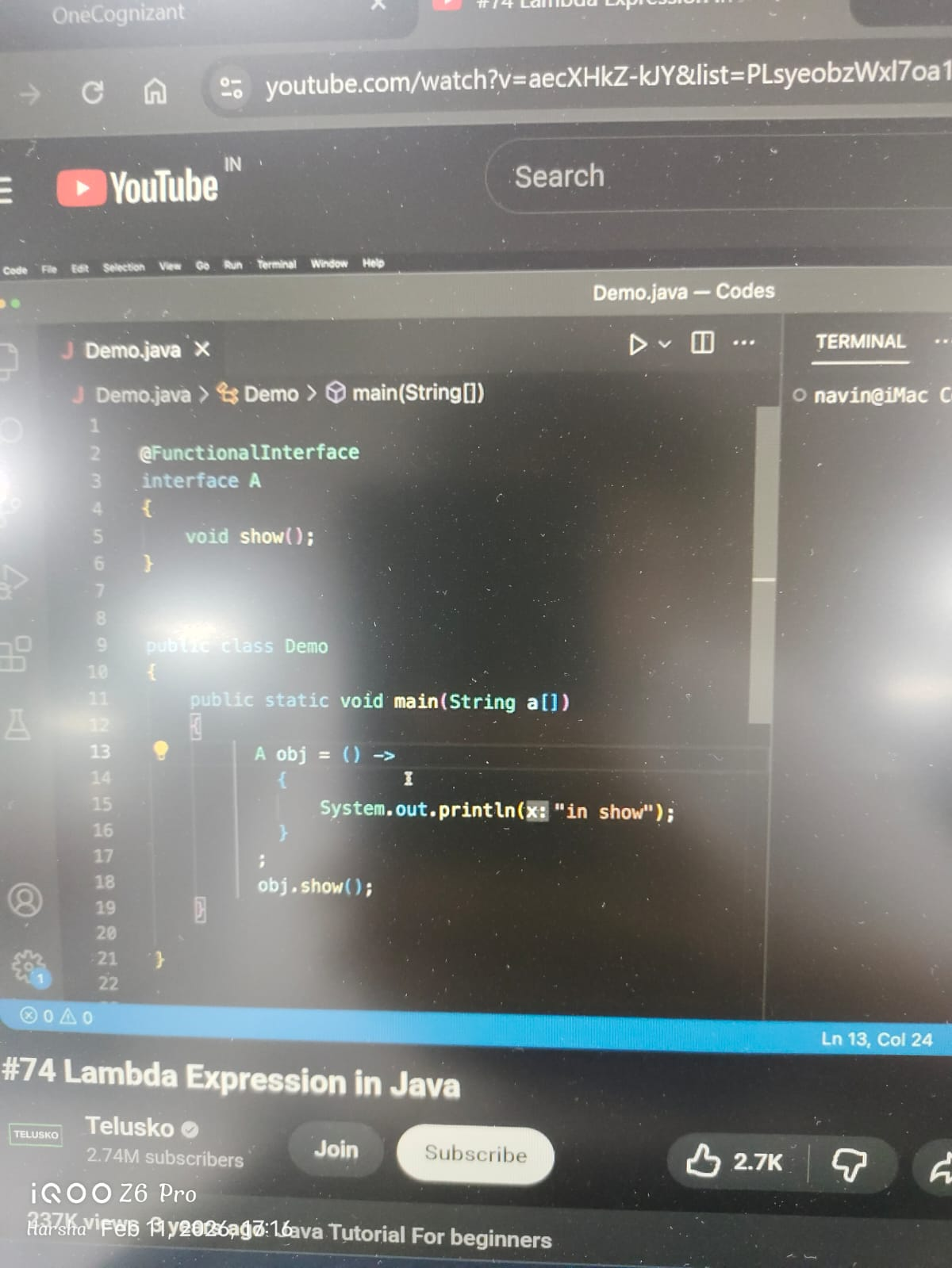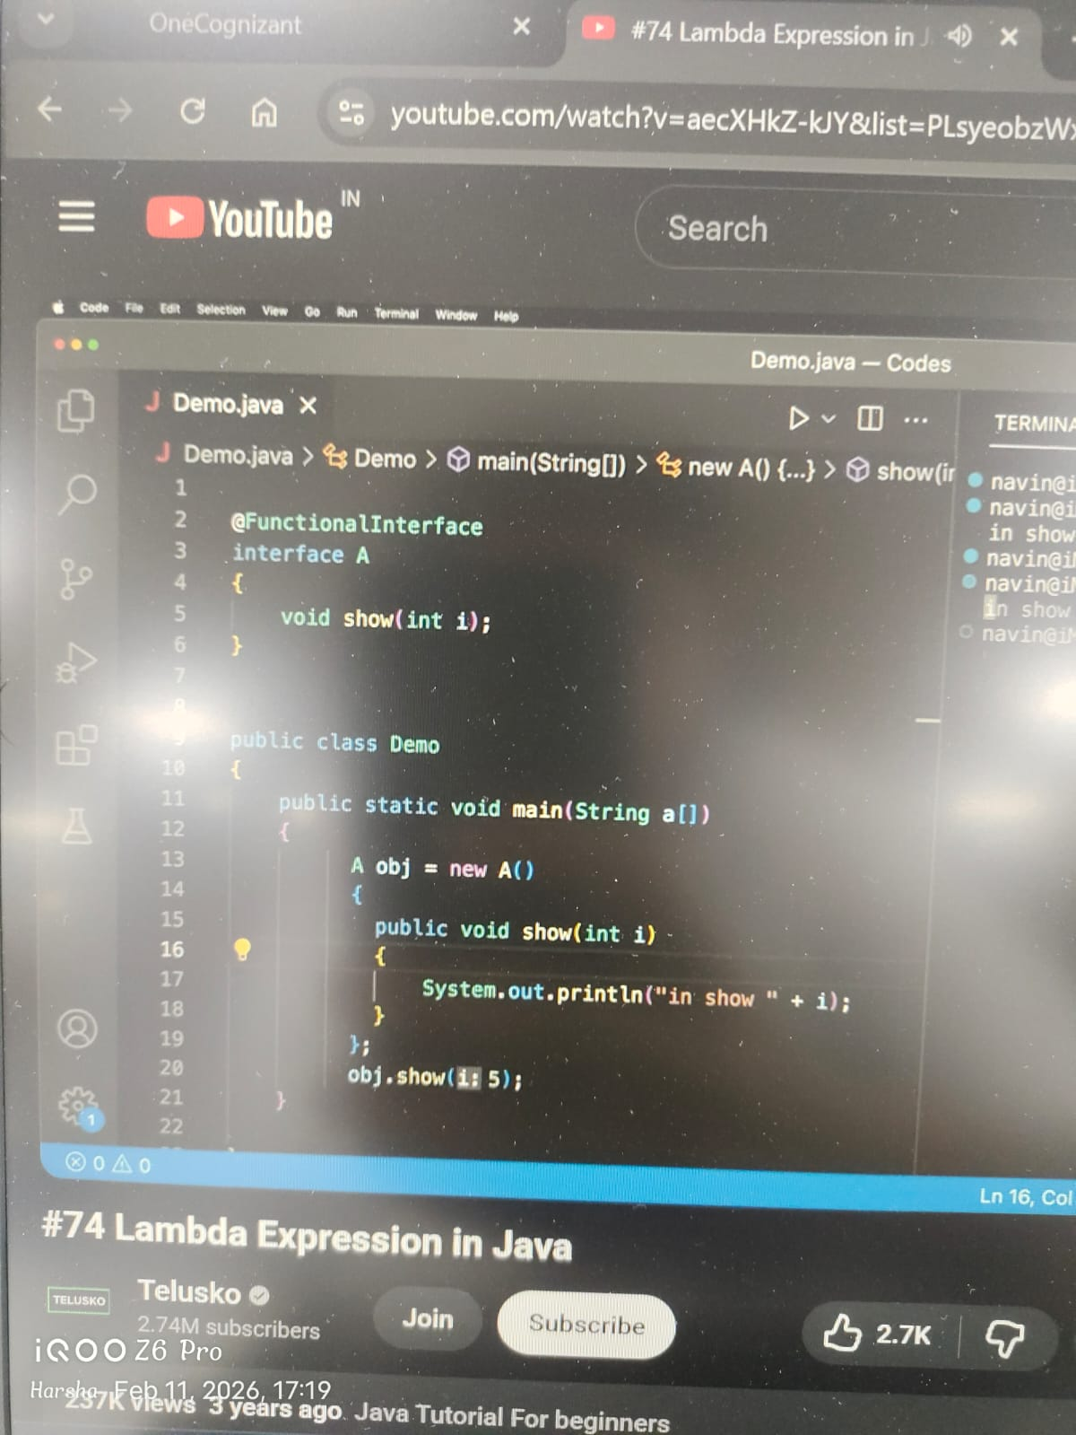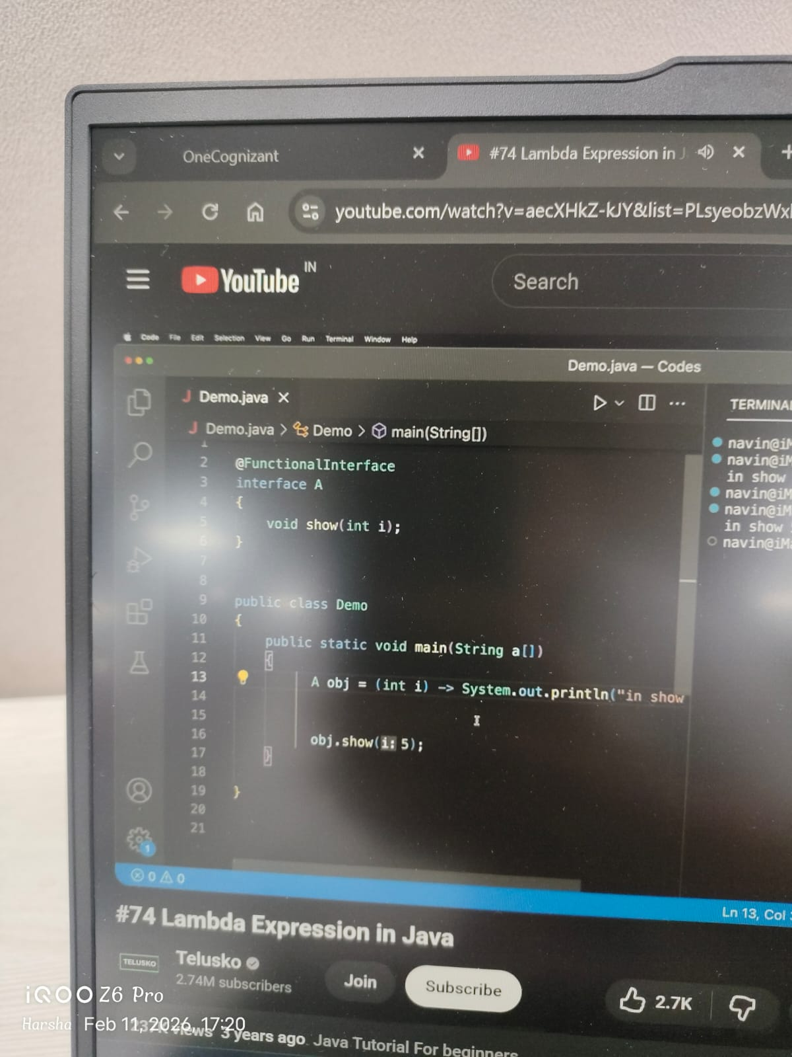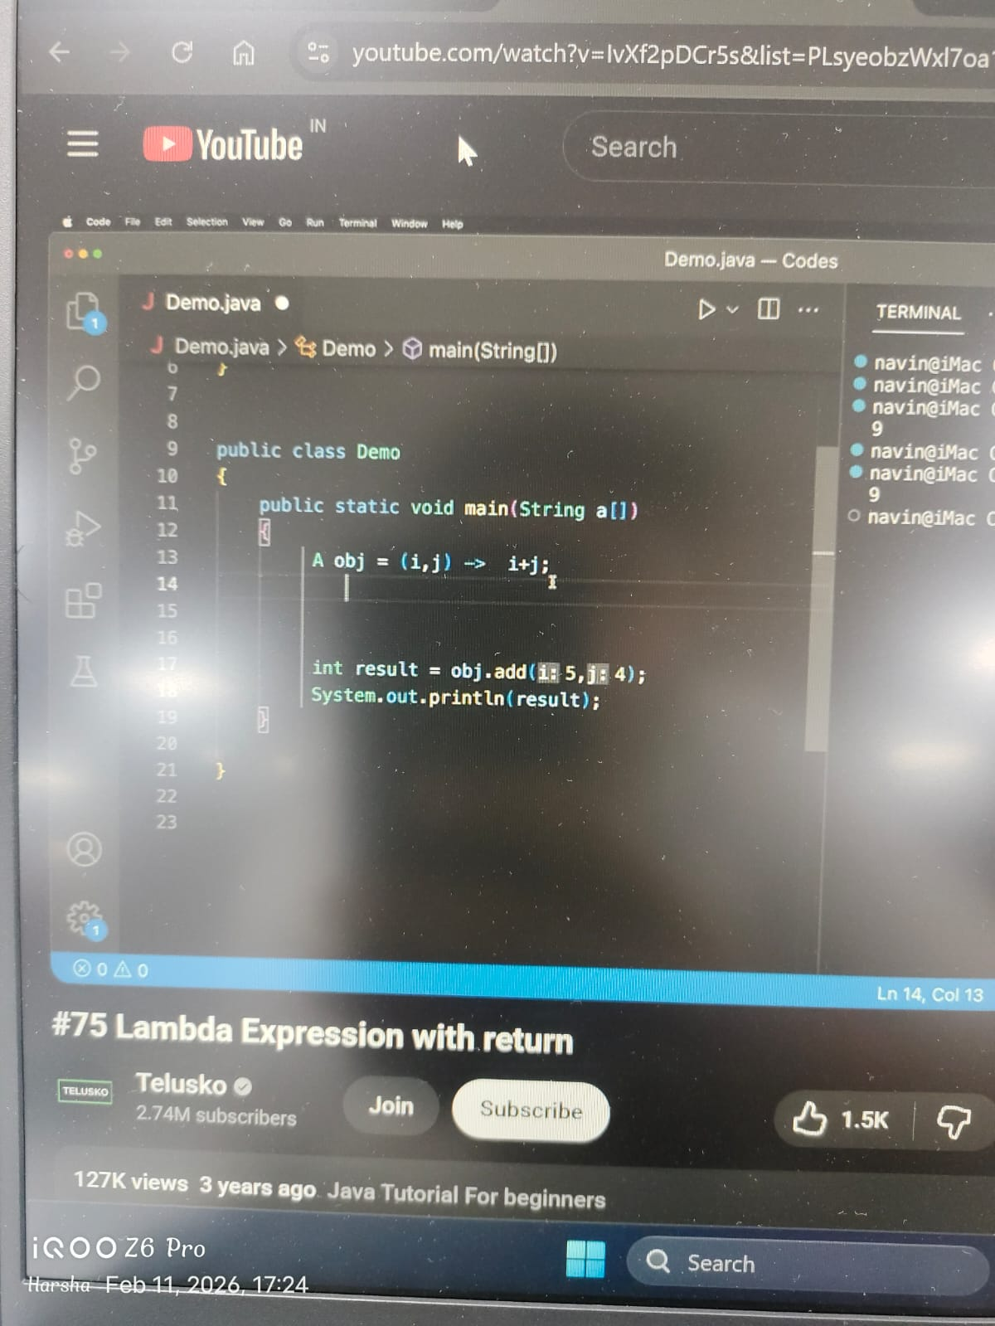

interface Powerable{
void turnOn();

default void CheckStatus(){
System.out.println("Checking System health....");
}
}

interface SmartDevice{}

abstract class Appliance implements Powerable{

String brand;

public Appliance(String brand){
this.brand=brand;
}

abstract void performTask();
}

class WashingMachine extends Appliance implements SmartDevice{

private int loadCapacity;

static int totalMachinesCreated=0;

{
System.out.println("Initializing new Washing Machine");
}

public WashingMachine(String brand, int loadCapacity){
super(brand);
this.loadCapacity=loadCapacity;
totalMachinesCreated++;
}

@Override
public void turnOn(){
System.out.println("washing machine turned on");
}

@Override
void performTask(){
System.out.println("Washing cloths");
}

}

public class Main{
public static void main(String []args){

WashingMachine w= new WashingMachine("Samsung",5);

w.turnOn();
w.CheckStatus();
w.performTask();

}
}

# Core Java
- -Oops
- -Java 8 features lambda functions
  - lambda functions work only for functional interface
- -Stream api
- -Jdbc

- -This , super by default parent class constructor will be called automatically
- Super.variavlename Super.methodname To access the superclass variables and functions

- -Multiple inheritance diamond problem
- -Final variable
- -Final class cannot be extended
- -Final method cannot be overided by other method in the child class
- -Collection framework
- -Stream API
- -Except handling try catch throw finally
- -Threads using inheritance and interface

- -String class and methods , overriding hashCode() , toString ()
- If u create an object of a class and u print the object it give Laptop@1af292qf
- Every time u try to print the object it will call the toString() function automatically
- Obj.toString()
- This prints the class name followed by @ symbol and hexadecimal code
- obj1.equals(obj2) actually it checks if the current obj is same as the other obj (reference) not based on their values

- -Platform independent

- -JVM platform dependent byte code is converted to native machine code Responsible for garbage collector bytecode verifier thread scheduler Each OS has its own implementation of JVM b/c JVM must convert the bytecode into native machine instructions Also managed memory heap stack garbage collection

- -JRE if u want to develop an application form scratch it provides the required environment Contains java class libraries, packages java . Lang util

- -JDK contains tools like java compiler It contains java tool kit for java developer's javac java Build java applications

- object class it's the super class of all the classes

- interface by default the methods are public abstract and all the variables used in interface are by default final and static
- If a variable is final then we should initialise it

- Class to class ---- extends
- Class to interface --- implements
- Interface to interface --- extends

- abstract class example shape and area
- inheritance reusability

1. The Concept of Immutability
In Java, the String class is immutable. This means that once a String object is created on the heap, its value cannot be changed.
- How it works: When you perform an operation like str.concat(" world"), Java doesn't modify the existing string. Instead, it creates a brand-new string object in memory and discards the old reference.
- Why? Immutability provides Security (usernames/passwords can't be changed mid-flow), Thread Safety (multiple threads can share a string without corruption), and Caching (the String Pool).

2. The String Pool
The String Pool is a special storage area within the Java Heap. It is a cache of String objects.
- Literal Creation: When you say String s = "Java", Java checks the pool. If "Java" already exists, it returns the existing reference. If not, it creates it.
- Keyword new: If you say String s = new String("Java"), you force Java to create a new object on the heap, outside the pool, even if "Java" already exists inside the pool.

3. String vs. StringBuffer vs. StringBuilder
If you are doing heavy text manipulation (like a loop appending 1,000 words), using String is expensive because it creates 1,000 objects. This is where Mutable sequences come in.
Feature | String | StringBuffer | StringBuilder
Mutability | Immutable (Fixed) | Mutable (Changeable) | Mutable (Changeable)
Thread Safety | Safe (due to immutability) | Safe (Synchronized) | Not Safe (Not Synchronized)
Performance | Slow for frequent updates | Medium | Fastest
Storage | String Pool / Heap | Heap | Heap
When to use what?
- String: Use when data won't change often or you're using simple literals.
- StringBuffer: Use in multi-threaded environments where multiple threads are updating the same string.
- StringBuilder: Use in single-threaded logic (like most local variables/backend logic) for maximum speed.

4. Implementation Example
Java
public class StringComparison {
public static void main(String[] args) {
// --- IMMUTABILITY & STRING POOL ---
String s1 = "Hello"; // Goes into String Pool
String s2 = "Hello"; // References the SAME object in Pool
String s3 = new String("Hello"); // Creates NEW object in Heap

System.out.println(s1 == s2); // true (Same memory address)
System.out.println(s1 == s3); // false (Different memory addresses)

// --- STRINGBUILDER (Mutable) ---
StringBuilder sb = new StringBuilder("Java");
sb.append(" Programming"); // Modifies the SAME object in memory
System.out.println(sb.toString()); // "Java Programming"

// --- THE "PASS BY VALUE" TRAP WITH STRINGS ---
String name = "Gemini";
changeName(name);
System.out.println("After method: " + name); // Still "Gemini" because Strings are immutable!
}

static void changeName(String n) {
n = n + " AI"; // This creates a new local object; original remains untouched
}
}
Summary of Memory Behavior
When you use StringBuilder or StringBuffer, Java uses a resizable array internally. Instead of creating new objects, it simply expands the internal buffer, which is significantly lighter on the Garbage Collector.

1. Functional Interface
🔹 What is a Functional Interface ?
A Functional Interface is an interface that contains exactly one abstract method.
👉 It may contain:
- multiple default methods
- multiple static methods
- methods from Object class
But it must contain only ONE abstract method.
This is important because functional interfaces are the target types for lambda expressions.

🔹 Syntax
@FunctionalInterface
interface InterfaceName {
void methodName();
}
👉 @FunctionalInterface is optional but recommended
It ensures the interface has only one abstract method.

🔹 Example 1 – Simple Functional Interface
@FunctionalInterface
interface Greeting {
void sayHello();
}
Implementation using normal class:
class MyGreeting implements Greeting {
public void sayHello() {
System.out.println("Hello World");
}
}
Usage:
public class Main {
public static void main(String[] args) {
Greeting g = new MyGreeting();
g.sayHello();
}
}

🔹 Example 2 – Functional Interface with Parameters
@FunctionalInterface
interface Add {
int sum(int a, int b);
}
Normal implementation:
class AddImpl implements Add {
public int sum(int a, int b) {
return a + b;
}
}

🔹 Built-in Functional Interfaces (Very Important)
Java provides many functional interfaces inside:
java.util.function
✔️ Common ones:
Interface | Purpose
Predicate<T> | condition check
Function<T,R> | transformation
Consumer<T> | consume data
Supplier<T> | produce data
Runnable | run task

Example – Predicate
import java.util.function.Predicate;

Predicate<Integer> isEven = n -> n % 2 == 0;

System.out.println(isEven.test(10));

✅ 2. Lambda Expressions
🔹 What is a Lambda Expression ?
A Lambda Expression is a short way to implement a functional interface.
Instead of writing:
- separate class
- anonymous class
You write inline implementation.
👉 Introduced in Java 8.

🔹 Basic Syntax
(parameters) -> { body }
Example:
(a, b) -> a + b

🔹 Example 1 – Without Lambda (Old Style)
interface Greeting {
void sayHello();
}

public class Main {
public static void main(String[] args) {

Greeting g = new Greeting() {
public void sayHello() {
System.out.println("Hello");
}
};

g.sayHello();
}
}

🔹 Example 2 – With Lambda (Modern Style)
Greeting g = () -> System.out.println("Hello");

g.sayHello();
🔥 Shorter
🔥 Cleaner
🔥 More readable

🔹 Example 3 – Lambda with Parameters
interface Add {
int sum(int a, int b);
}

public class Main {
public static void main(String[] args) {

Add add = (a, b) -> a + b;

System.out.println(add.sum(10, 20));
}
}

🔹 Example 4 – Lambda with Collections (Very Important)
Before Java 8:
for(String name : list) {
System.out.println(name);
}
With Lambda:
list.forEach(name -> System.out.println(name));

🔹 Example 5 – Sorting using Lambda
import java.util.*;

public class Main {
public static void main(String[] args) {

List<Integer> list = Arrays.asList(5,3,1,4);

list.sort((a, b) -> a - b);

System.out.println(list);
}
}

🔹 Lambda Expression Variations
1️⃣ No parameter
() -> System.out.println("Hello");

2️⃣ Single parameter
n -> n * 2
(No need brackets)

3️⃣ Multiple parameters
(a, b) -> a + b

4️⃣ Multiple statements
(a, b) -> {
int sum = a + b;
return sum;
};

✅ How Functional Interface & Lambda Work Together
👉 Functional Interface = Target Type
👉 Lambda = Implementation
Example:
interface Printer {
void print(String msg);
}

Printer p = message -> System.out.println(message);

✅ Advantages
✔️ Less Boilerplate Code
No need separate class.
✔️ Functional Programming Support
Used with streams & collections.
✔️ Improves Readability
Cleaner logic.
✔️ Enables Parallel Processing
Used in Stream API.

✅ Real-World Usage (Spring Boot + Java Full Stack)
You will see lambdas in:
- Streams API
- CompletableFuture
- Event Listeners
- Filtering Collections
- Async Processing
- Reactive Programming
Example:
users.stream()
.filter(u -> u.getAge() > 18)
.forEach(u -> System.out.println(u.getName()));

🔥 Super Important Interview Points
✔️ Lambda works only with Functional Interface
✔️ Functional Interface → Single Abstract Method
✔️ Lambda reduces anonymous class usage
✔️ @FunctionalInterface is optional but recommended
✔️ Lambda improves functional programming style

The try and catch Blocks
These two work as a pair. The try block contains the code that might cause an error, and the catch block contains the code that handles the error if it happens.
- Try: "Try running this code."
- Catch: "If a specific error occurs, catch it here and do something about it."
Java Example:
Java
public class TryCatchExample {
public static void main(String[] args) {
try {
int division = 10 / 0; // This will throw an ArithmeticException
System.out.println("This line will never execute.");
} catch (ArithmeticException e) {
System.out.println("Error: You cannot divide by zero!");
System.out.println("Message: " + e.getMessage());
}
System.out.println("The program continues running safely...");
}
}

2. The throw Keyword
While try-catch is used to handle exceptions, throw is used to explicitly create one. You use this when a specific condition in your logic isn't met (e.g., a user enters a negative age).
Java Example:
Java
public class ThrowExample {
static void checkAge(int age) {
if (age < 18) {
// We manually throw an exception
throw new ArithmeticException("Access denied - You must be at least 18 years old.");
} else {
System.out.println("Access granted!");
}
}

public static void main(String[] args) {
checkAge(15);
}
}

3. The throws Keyword
The throws keyword is used in a method signature. It’s a warning to anyone calling the method: "Hey, this method might cause an exception. You better handle it with a try-catch, or pass it up the line."
It is primarily used for Checked Exceptions (errors the compiler forces you to acknowledge, like IOException).
Java Example:
Java
import java.io.*;

public class ThrowsExample {
// This method warns that it might throw an IOException
static void findFile() throws IOException {
File newFile = new File("test.txt");
FileInputStream stream = new FileInputStream(newFile);
}

public static void main(String[] args) {
try {
findFile();
} catch (IOException e) {
System.out.println("File not found: " + e.getMessage());
}
}
}

Summary Comparison Table
Keyword | Purpose | Where it's used
try | Wraps code that might fail. | Inside a method body.
catch | Handles the exception thrown by try. | Immediately follows the try block.
throw | Manually throws a specific exception. | Inside a method body.
throws | Declares that a method might throw an exception. | In the method signature (header).
Export to Sheets

Putting it all together
In a real-world scenario, you might use these together to ensure your application remains stable even when users provide bad data.
Pro Tip: Always catch specific exceptions (like NullPointerException) rather than the general Exception class. It makes debugging much easier!
Would you like me to create a custom exception class for you to show how to handle unique business logic errors?

The Multi-Exception Scenario
In this example, we manually throw exceptions if the user data is invalid, and the method throws a checked exception to signal that a file operation might fail.
import java.io.IOException;

public class RegistrationSystem {

// 'throws' indicates this method might fail with an IOException
public static void registerUser(String username, int age) throws IOException {

// 1. Using 'throw' for business logic (Unchecked Exception)
if (age < 13) {
throw new ArithmeticException("Underage: Users must be at least 13.");
}

// 2. Using 'throw' for data validation (Unchecked Exception)
if (username == null || username.length() < 3) {
throw new IllegalArgumentException("Invalid Username: Minimum 3 characters required.");
}

// 3. Simulating a 'throw' for a system error (Checked Exception)
if (username.equals("admin")) {
throw new IOException("Database Error: 'admin' is a reserved system name.");
}

System.out.println("User " + username + " registered successfully!");
}

public static void main(String[] args) {
// Test Case 1: Too young
try {
registerUser("jdoe", 10);
} catch (Exception e) {
System.out.println("Caught Error: " + e.getMessage());
}

// Test Case 2: Bad username
try {
registerUser("jo", 20);
} catch (Exception e) {
System.out.println("Caught Error: " + e.getMessage());
}

// Test Case 3: Reserved name (Checked Exception)
try {
registerUser("admin", 25);
} catch (IOException e) {
System.out.println("Caught File/DB Error: " + e.getMessage());
}
}
}

Key Takeaways from this Code:
- Multiple throw statements: Notice how we use throw inside the method to stop the execution immediately if something is wrong. Once a throw is hit, the rest of the method is skipped.
- The throws Declaration: Because the method potentially throws an IOException (a Checked Exception), we must declare it in the method signature: void registerUser(...) throws IOException.
- Specific vs. General Catch: In the main method, I caught specific types. If you catch ArithmeticException, it won't catch the IOException. This is why we often have multiple catch blocks or a general Exception catch for safety.
Handling Multiple Exceptions in one Block
If you want to handle different exceptions the same way without writing multiple catch blocks, Java allows a "Multi-catch" using the pipe | symbol:
Java
try {
registerUser("test", 5);
} catch (ArithmeticException | IllegalArgumentException e) {
// This catches either of the two logic-related exceptions
System.out.println("Validation failed: " + e.getMessage());
} catch (IOException e) {
// This catches the checked exception
System.out.println("System failure: " + e.getMessage());
}

The "Chain of Responsibility"
When a method uses throws, it’s essentially saying: "I know an error might happen here, but I don't want to deal with it. Whoever calls me needs to handle it."
Java Code: Multiple Exceptions in throws
In this example, the processData method warns that it might fail for three different reasons. Notice how the main method is then forced to deal with those possibilities.
Java
import java.io.IOException;
import java.sql.SQLException;
import java.rmi.RemoteException;

public class MultiThrowsExample {

// This method 'throws' three different checked exceptions
// It doesn't use try-catch; it just passes the risk upward
public static void processData(int sourceId)
throws IOException, SQLException, RemoteException {

if (sourceId == 1) {
throw new IOException("Failed to read the local file.");
} else if (sourceId == 2) {
throw new SQLException("Database connection refused.");
} else if (sourceId == 3) {
throw new RemoteException("Cloud server is unreachable.");
}

System.out.println("Data processed successfully!");
}

public static void main(String[] args) {
// Because processData 'throws' exceptions, main MUST handle them
try {
processData(2);
}
catch (IOException e) {
System.out.println("File Error: " + e.getMessage());
}
catch (SQLException e) {
System.out.println("Database Error: " + e.getMessage());
}
catch (RemoteException e) {
System.out.println("Network Error: " + e.getMessage());
}

System.out.println("The program finished safely.");
}
}

When to use throws vs. try-catch
Scenario | Use throws? | Use try-catch?
You can't fix the error inside the method. | Yes (Pass it up) | No
You want the calling method to decide the fix. | Yes | No
You are at the "top level" (like a UI button click). | No | Yes (Handle it here)
You want the program to keep running after a failure. | No | Yes

Important Rules for throws
- Multiple Exceptions: You can list as many as you want, separated by commas: throws Exception1, Exception2.
- The Hierarchy Rule: If you throw IOException, you can just say throws Exception (the parent), but it's better practice to be specific.
- Unchecked Exceptions: You can list unchecked exceptions (like ArithmeticException) in a throws clause, but Java doesn't require it. It's usually only done for document

Threads in Java
A thread in Java is a lightweight unit of execution within a program. It allows multiple tasks to run concurrently, improving efficiency and responsiveness, especially in applications like servers, GUIs, and real-time systems.
Key Characteristics
- Each thread runs independently but shares the same process resources (memory, files).
- Java provides multithreading, enabling multiple threads to run simultaneously.
- Threads can be created by:
  - Extending the Thread class.
  - Implementing the Runnable interface.
- Managed by the Java Virtual Machine (JVM).

Thread Lifecycle
A thread in Java goes through several states:
- New – Created but not started (new Thread()).
- Runnable – Ready to run, waiting for CPU scheduling.
- Running – Actively executing.
- Waiting/Timed Waiting – Paused, waiting for another thread or timeout.
- Terminated – Finished execution.

Important Methods
- start() – Starts the thread.
- run() – Defines the thread’s task.
- sleep(long ms) – Pauses execution.
- join() – Waits for another thread to finish.
- yield() – Suggests scheduler to switch to another thread.
- interrupt() – Interrupts a thread.
- isAlive() – Checks if thread is still running.

Java Code Demonstration
1. Extending Thread Class
class MyThread extends Thread {
public void run() {
System.out.println("Thread running: " + Thread.currentThread().getName());
}
}

public class ThreadDemo {
public static void main(String[] args) {
MyThread t1 = new MyThread();
t1.start();
}
}
2. Implementing Runnable Interface
class MyRunnable implements Runnable {
public void run() {
System.out.println("Runnable thread running: " + Thread.currentThread().getName());
}
}

public class RunnableDemo {
public static void main(String[] args) {
Thread t1 = new Thread(new MyRunnable());
t1.start();
}
}
3. Using ExecutorService (Modern Approach)
import java.util.concurrent.*;

public class ExecutorDemo {
public static void main(String[] args) {
ExecutorService executor = Executors.newFixedThreadPool(2);

executor.execute(() -> System.out.println("Task 1 running"));
executor.execute(() -> System.out.println("Task 2 running"));

executor.shutdown();
}
}

Advantages of Threads
- Better CPU utilization.
- Enables parallelism.
- Improves responsiveness in GUIs.
- Useful in server applications handling multiple clients.
Challenges
- Synchronization issues (race conditions).
- Deadlocks if resources are mismanaged.
- Debugging multithreaded programs can be complex.

Would you like me to export this Threads in Java explanation and code into a Word document as well, so it matches the format of your LinkedList, Vector, HashSet, LinkedHashSet, TreeSet, HashMap, Hashtable, and PriorityQueue documents?

Naming Collisions in Java
Naming collisions occur when two or more identifiers (classes, interfaces, methods, or variables) share the same name in a way that causes ambiguity or conflict in the code.
Types of Naming Collisions:
- Class vs. Interface Collision: When a class and an interface have the same name in the same package.
- Interface Method Collision: When a class implements multiple interfaces that declare methods with the same signature.
- Variable Collision: When interfaces declare variables with the same name, and a class implementing them faces ambiguity.
Example – Method Collision:
interface Animal {
void makeSound();
}

interface Machine {
void makeSound();
}

class RobotDog implements Animal, Machine {
@Override
public void makeSound() {
System.out.println("This serves both Animal and Machine!");
}
}
Here, RobotDog must provide a single implementation of makeSound(), even though both interfaces define it. This can lead to design confusion because the same method is serving two different conceptual purposes.

Wrapper Classes in Java
Wrapper classes are object representations of primitive data types. They allow primitives to be used in contexts that require objects, such as collections, generics, and APIs.
Primitive Types and Their Wrapper Classes:
Primitive | Wrapper Class
byte | Byte
short | Short
int | Integer
long | Long
float | Float
double | Double
char | Character
boolean | Boolean
Key Features:
- Autoboxing: Automatic conversion of primitive to wrapper object.
- Unboxing: Automatic conversion of wrapper object back to primitive.
- Utility Methods: Wrapper classes provide methods like valueOf(), parseInt(), toString().
Example – Autoboxing and Unboxing:
public class WrapperDemo {
public static void main(String[] args) {
int num = 100;

// Autoboxing: primitive to object
Integer obj = num;

// Unboxing: object to primitive
int primitive = obj;

System.out.println("Integer object: " + obj);
System.out.println("Primitive int: " + primitive);
}
}
This allows primitives to be stored in collections like ArrayList<Integer> (since collections only store objects).

Putting It Together
- Naming collisions highlight challenges in interface design and multiple inheritance scenarios in Java.
- Wrapper classes solve the problem of primitives not being objects, enabling seamless integration with Java’s object-oriented features.
Would you like me to also create a side-by-side comparison table showing how naming collisions and wrapper classes differ in purpose, problem solved, and usage? That could make the contrast even clearer.
Autoboxing and Unboxing in Java
Java introduced autoboxing and unboxing in JDK 5 to make working with primitives and wrapper classes more seamless.

Autoboxing
Autoboxing is the automatic conversion of a primitive type into its corresponding wrapper class object.
- Example: int → Integer, double → Double
- This happens when a primitive is assigned to a variable of a wrapper type or passed to a method expecting an object.
public class AutoBoxingExample {
public static void main(String[] args) {
int num = 10;

// Autoboxing: primitive int → Integer object
Integer obj = num;

System.out.println("Integer object: " + obj);
}
}

Unboxing
Unboxing is the reverse process: automatic conversion of a wrapper class object back into its primitive type.
public class UnboxingExample {
public static void main(String[] args) {
Integer obj = 25;

// Unboxing: Integer object → primitive int
int num = obj;

System.out.println("Primitive int: " + num);
}
}

Combined Example
Autoboxing and unboxing often occur together, especially in collections and arithmetic operations.
import java.util.ArrayList;

public class AutoBoxingUnboxingDemo {
public static void main(String[] args) {
ArrayList<Integer> list = new ArrayList<>();

// Autoboxing: int → Integer
list.add(5);
list.add(10);

// Unboxing: Integer → int
int sum = 0;
for (Integer i : list) {
sum += i; // unboxing happens here
}

System.out.println("Sum: " + sum);
}
}

Why It Matters
- Before JDK 5: You had to manually wrap and unwrap primitives using methods like Integer.valueOf() and intValue().
- After JDK 5: Autoboxing/unboxing makes code cleaner and more intuitive.
- Use Case: Collections (ArrayList, HashMap) only store objects, so primitives must be boxed into wrappers.

Would you like me to also show common pitfalls of autoboxing/unboxing, like NullPointerException when unboxing a null wrapper, and performance overhead in tight loops? That’s where developers often get caught off guard.

Lambda Functions in Java
Lambda expressions (often called lambda functions) were introduced in Java 8. They allow you to write short, anonymous functions that can be treated as objects. This makes Java more expressive and functional in style.

Key Characteristics
- Anonymous: No need to declare a separate method or class.
- Concise: Reduces boilerplate code.
- Functional Interface: Lambdas can only be used where a functional interface (an interface with exactly one abstract method) is expected. Examples: Runnable, Comparator, Callable.
- Syntax:
- (parameters) -> expression
- (parameters) -> { statements }

Example 1: Simple Lambda
interface Add {
int addition(int a, int b);
}

public class LambdaDemo {
public static void main(String[] args) {
// Lambda expression implementing Add interface
Add add = (a, b) -> a + b;

System.out.println("Sum: " + add.addition(10, 20));
}
}
Output:
Sum: 30
This replaces the need for an anonymous inner class.

Example 2: Using Lambda with Runnable
public class RunnableLambda {
public static void main(String[] args) {
// Traditional way
Runnable r1 = new Runnable() {
public void run() {
System.out.println("Running in old style");
}
};

// Lambda way
Runnable r2 = () -> System.out.println("Running with Lambda");

r1.run();
r2.run();
}
}

Example 3: Lambda with Collections
import java.util.*;

public class LambdaCollections {
public static void main(String[] args) {
List<String> names = Arrays.asList("Harsha", "Anita", "Ravi");

// Using lambda with forEach
names.forEach(name -> System.out.println(name));

// Using lambda with sort
names.sort((a, b) -> a.compareTo(b));
System.out.println("Sorted: " + names);
}
}

Example 4: Multi-Statement Lambda
interface Greeting {
void sayHello(String name);
}

public class MultiStatementLambda {
public static void main(String[] args) {
Greeting greet = (name) -> {
System.out.println("Hello, " + name);
System.out.println("Welcome to Java Lambdas!");
};

greet.sayHello("Harsha");
}
}

Benefits of Lambdas
- Cleaner code with fewer lines.
- Encourages functional programming style.
- Works seamlessly with Java Streams API.
- Makes event handling and callbacks more elegant.

In short, lambda functions let you treat behavior as data—passing code around just like variables. They’re especially powerful when combined with streams and functional interfaces.
Would you like me to extend this into Java Streams examples (like filtering, mapping, reducing with lambdas)? That’s where lambdas really shine in real-world applications.
Functional Interfaces in Java
A functional interface is an interface that contains exactly one abstract method. It can have multiple default or static methods, but only one abstract method. Functional interfaces are the foundation of lambda expressions and method references in Java.

Key Points
- Introduced in Java 8 to support functional programming.
- Annotated with @FunctionalInterface (optional but recommended).
- Can be implemented using lambda expressions, method references, or anonymous classes.
- Examples in Java’s standard library:
  - Runnable (method: run())
  - Callable<V> (method: call())
  - Comparator<T> (method: compare(T o1, T o2))
  - Function<T,R> (method: apply(T t))
  - Predicate<T> (method: test(T t))

Example 1: Custom Functional Interface
@FunctionalInterface
interface MyFunctionalInterface {
void sayMessage(String msg);
}

public class FunctionalInterfaceDemo {
public static void main(String[] args) {
// Using lambda expression
MyFunctionalInterface message = (msg) -> System.out.println("Message: " + msg);

message.sayMessage("Hello Functional Interface!");
}
}
Output:
Message: Hello Functional Interface!

Example 2: Using Built-in Functional Interface (Predicate)
import java.util.function.Predicate;

public class PredicateDemo {
public static void main(String[] args) {
Predicate<Integer> isEven = num -> num % 2 == 0;

System.out.println("Is 10 even? " + isEven.test(10));
System.out.println("Is 7 even? " + isEven.test(7));
}
}
Output:
Is 10 even? true
Is 7 even? false

Example 3: Functional Interface with Method Reference
@FunctionalInterface
interface Printer {
void print(String msg);
}

public class MethodReferenceDemo {
public static void main(String[] args) {
// Method reference instead of lambda
Printer printer = System.out::println;

printer.print("Printing using method reference!");
}
}

Why Functional Interfaces Matter
- Enable lambda expressions and stream API usage.
- Promote cleaner, more concise code.
- Provide a bridge between object-oriented and functional programming styles.

In short, functional interfaces are the contracts that allow lambdas to exist in Java. They define the single abstract method that a lambda or method reference can implement.
Would you like me to also walk through how functional interfaces power the Java Streams API (like map, filter, reduce), since that’s where they become most practical and powerful?
Java provides a rich set of predefined functional interfaces in the java.util.function package (introduced in Java 8). These interfaces are designed to support lambda expressions and method references, making functional programming easier and more expressive.

Core Predefined Functional Interfaces
Interface | Abstract Method | Purpose | Example Usage
Predicate | boolean test(T t) | Tests a condition and returns true/false. | Predicate<Integer> isEven = n -> n % 2 == 0;
Function<T,R> | R apply(T t) | Maps input of type T to output of type R. | Function<String, Integer> length = s -> s.length();
Consumer | void accept(T t) | Performs an action on input without returning a result. | Consumer<String> print = s -> System.out.println(s);
Supplier | T get() | Supplies a value without taking input. | Supplier<Double> random = () -> Math.random();
BiPredicate<T,U> | boolean test(T t, U u) | Tests a condition on two inputs. | BiPredicate<String, Integer> longerThan = (s, n) -> s.length() > n;
BiFunction<T,U,R> | R apply(T t, U u) | Maps two inputs to a single output. | BiFunction<Integer, Integer, Integer> add = (a, b) -> a + b;
BiConsumer<T,U> | void accept(T t, U u) | Performs an action on two inputs. | BiConsumer<String, Integer> printPair = (s, n) -> System.out.println(s + " : " + n);

Specialized Variants for Primitives
To avoid boxing/unboxing overhead, Java provides primitive-specific functional interfaces:
- IntPredicate, LongPredicate, DoublePredicate
- IntFunction, LongFunction, DoubleFunction
- IntConsumer, LongConsumer, DoubleConsumer
- IntSupplier, LongSupplier, DoubleSupplier
- IntUnaryOperator, LongUnaryOperator, DoubleUnaryOperator
- IntBinaryOperator, LongBinaryOperator, DoubleBinaryOperator

Operator Interfaces
- UnaryOperator → A Function<T,T> (takes one input, returns same type).
- BinaryOperator → A BiFunction<T,T,T> (takes two inputs of same type, returns same type).

Here’s a set of clear example codes for the predefined functional interfaces in Java. Each snippet shows how the interface is typically used with lambdas.

1. Predicate
Tests a condition and returns true or false.
import java.util.function.Predicate;

public class PredicateExample {
public static void main(String[] args) {
Predicate<Integer> isEven = n -> n % 2 == 0;

System.out.println(isEven.test(10)); // true
System.out.println(isEven.test(7)); // false
}
}

2. Function<T,R>
Maps input of type T to output of type R.
import java.util.function.Function;

public class FunctionExample {
public static void main(String[] args) {
Function<String, Integer> length = s -> s.length();

System.out.println(length.apply("Java")); // 4
}
}

3. Consumer
Consumes input and performs an action without returning a result.
import java.util.function.Consumer;

public class ConsumerExample {
public static void main(String[] args) {
Consumer<String> print = s -> System.out.println("Hello " + s);

print.accept("Harsha");
}
}

4. Supplier
Supplies a value without taking input.
import java.util.function.Supplier;

public class SupplierExample {
public static void main(String[] args) {
Supplier<Double> randomValue = () -> Math.random();

System.out.println(randomValue.get());
}
}

5. BiPredicate<T,U>
Tests a condition on two inputs.
import java.util.function.BiPredicate;

public class BiPredicateExample {
public static void main(String[] args) {
BiPredicate<String, Integer> longerThan = (s, n) -> s.length() > n;

System.out.println(longerThan.test("Hello", 3)); // true
System.out.println(longerThan.test("Hi", 5)); // false
}
}

6. BiFunction<T,U,R>
Maps two inputs to a single output.
import java.util.function.BiFunction;

public class BiFunctionExample {
public static void main(String[] args) {
BiFunction<Integer, Integer, Integer> add = (a, b) -> a + b;

System.out.println(add.apply(5, 7)); // 12
}
}

7. BiConsumer<T,U>
Consumes two inputs and performs an action.
import java.util.function.BiConsumer;

public class BiConsumerExample {
public static void main(String[] args) {
BiConsumer<String, Integer> printPair = (s, n) -> System.out.println(s + " : " + n);

printPair.accept("Age", 25);
}
}

8. UnaryOperator
A Function<T,T> (takes one input, returns same type).
import java.util.function.UnaryOperator;

public class UnaryOperatorExample {
public static void main(String[] args) {
UnaryOperator<Integer> square = n -> n * n;

System.out.println(square.apply(6)); // 36
}
}

9. BinaryOperator
A BiFunction<T,T,T> (takes two inputs of same type, returns same type).
import java.util.function.BinaryOperator;

public class BinaryOperatorExample {
public static void main(String[] args) {
BinaryOperator<Integer> multiply = (a, b) -> a * b;

System.out.println(multiply.apply(4, 5)); // 20
}
}

These examples cover the most commonly used predefined functional interfaces. They form the backbone of Java’s Streams API and functional programming style.
Would you like me to now show how these interfaces are applied in Streams (like filter with Predicate, map with Function, reduce with BinaryOperator)? That’s where they become most powerful in real-world coding.

Method References in Java
Method references are a shorthand way of writing lambda expressions when the lambda simply calls an existing method. They were introduced in Java 8 and use the double colon operator (::). They make code more concise and readable.

Types of Method References
- Reference to a Static Method
  - Syntax: ClassName::staticMethodName
- import java.util.Arrays;

- public class StaticMethodRef {
- public static void print(String s) {
- System.out.println(s);
- }

- public static void main(String[] args) {
- String[] names = {"Geek1", "Geek2", "Geek3"};

- // Using method reference instead of lambda
- Arrays.stream(names).forEach(StaticMethodRef::print);
- }
- }
Output:
Geek1
Geek2
Geek3

- Reference to an Instance Method of a Particular Object
  - Syntax: object::instanceMethodName
- public class InstanceMethodRef {
- public void printMessage(String msg) {
- System.out.println(msg);
- }

- public static void main(String[] args) {
- InstanceMethodRef obj = new InstanceMethodRef();

- Runnable r = () -> obj.printMessage("Hello with Lambda");
- r.run();

- // Using method reference
- Runnable r2 = obj::printMessage;
- r2.run();
- }
- }
Output:
Hello with Lambda
Hello with Lambda

- Reference to an Instance Method of an Arbitrary Object of a Particular Type
  - Syntax: ClassName::instanceMethodName
- import java.util.*;

- public class ArbitraryObjectMethodRef {
- public static void main(String[] args) {
- List<String> names = Arrays.asList("Harsha", "Anita", "Ravi");

- // Using lambda
- names.forEach(name -> System.out.println(name));

- // Using method reference
- names.forEach(System.out::println);
- }
- }
Output:
Harsha
Anita
Ravi

- Reference to a Constructor
  - Syntax: ClassName::new
- import java.util.function.Supplier;

- class Student {
- String name;
- Student() {
- this.name = "Default Student";
- }
- }

- public class ConstructorRef {
- public static void main(String[] args) {
- // Using lambda
- Supplier<Student> s1 = () -> new Student();

- // Using constructor reference
- Supplier<Student> s2 = Student::new;

- System.out.println(s1.get().name);
- System.out.println(s2.get().name);
- }
- }
Output:
Default Student
Default Student

Why Use Method References?
- Cleaner code: Avoids redundant lambda expressions.
- Readability: Directly shows which method is being called.
- Integration: Works seamlessly with functional interfaces and streams.

In short, method references are syntactic sugar for lambdas when the lambda body is just a call to an existing method. They make functional programming in Java more elegant.
Would you like me to also show how method references combine with Streams API (like map, filter, collect) to make real-world code even more concise?
Stream API in Java
The Stream API, introduced in Java 8, provides a modern, functional way to process collections of data. A stream represents a sequence of elements and supports operations such as filtering, mapping, sorting, and reducing. Unlike collections, streams don’t store data; they convey elements from a source (like a list, array, or I/O channel) through a pipeline of operations.

Key Concepts
- Stream Pipeline: A stream is processed through a pipeline of operations:
  - Source → Collection, array, or I/O channel.
  - Intermediate Operations → Transformations (e.g., filter, map, sorted). These return another stream.
  - Terminal Operations → Produce a result (e.g., collect, forEach, reduce).
- Lazy Evaluation: Intermediate operations are not executed until a terminal operation is invoked.
- Parallel Streams: Streams can run in parallel for performance gains (parallelStream()).

Example 1: Filtering and Printing
import java.util.*;
import java.util.stream.*;

public class StreamFilterExample {
public static void main(String[] args) {
List<String> names = Arrays.asList("Harsha", "Anita", "Ravi", "Arun");

names.stream()
.filter(name -> name.startsWith("A"))
.forEach(System.out::println);
}
}
Output:
Anita
Arun

Example 2: Mapping and Collecting
import java.util.*;
import java.util.stream.*;

public class StreamMapExample {
public static void main(String[] args) {
List<String> names = Arrays.asList("Harsha", "Anita", "Ravi");

List<Integer> lengths = names.stream()
.map(String::length)
.collect(Collectors.toList());

System.out.println(lengths);
}
}
Output:
[6, 5, 4]

Example 3: Reducing (Aggregation)
import java.util.*;
import java.util.stream.*;

public class StreamReduceExample {
public static void main(String[] args) {
List<Integer> numbers = Arrays.asList(1, 2, 3, 4, 5);

int sum = numbers.stream()
.reduce(0, (a, b) -> a + b);

System.out.println("Sum: " + sum);
}
}
Output:
Sum: 15

Example 4: Sorting
import java.util.*;
import java.util.stream.*;

public class StreamSortExample {
public static void main(String[] args) {
List<String> names = Arrays.asList("Harsha", "Anita", "Ravi");

names.stream()
.sorted()
.forEach(System.out::println);
}
}
Output:
Anita
Harsha
Ravi

Example 5: Parallel Stream
import java.util.*;
import java.util.stream.*;

public class ParallelStreamExample {
public static void main(String[] args) {
List<Integer> numbers = Arrays.asList(1,2,3,4,5,6,7,8,9,10);

int sum = numbers.parallelStream()
.reduce(0, Integer::sum);

System.out.println("Parallel Sum: " + sum);
}
}

Why Stream API Matters
- Declarative style: Focus on what to do, not how.
- Less boilerplate: Cleaner and shorter code.
- Functional programming: Works seamlessly with lambdas and method references.
- Performance: Parallel streams can leverage multicore processors.

Would you like me to extend this into a real-world example (like processing employee records with filter, map, and groupingBy) to show how Streams simplify complex data operations?

1. Filter
How it works: It acts as a gatekeeper. It takes a Predicate (a condition that returns true or false) and only lets the elements that satisfy the condition pass through to the next stage.
Java
List<String> names = Arrays.asList("Alice", "Bob", "Charlie", "David");
List<String> result = names.stream()
.filter(name -> name.startsWith("C"))
.collect(Collectors.toList());
// Output: [Charlie]

2. Map
How it works: It is used for transformation. It takes a function and applies it to every element in the stream, converting it into something else (e.g., turning a string into its length or an object into one of its fields).
Java
List<String> names = Arrays.asList("apple", "banana");
List<Integer> lengths = names.stream()
.map(String::length)
.collect(Collectors.toList());
// Output: [5, 6]

3. Sorted
How it works: It sorts the elements in the stream. By default, it uses "natural order" (alphabetical or numerical), but you can also provide a custom Comparator to define your own sorting logic.
Java
List<Integer> numbers = Arrays.asList(5, 1, 3, 2, 4);
List<Integer> sortedNumbers = numbers.stream()
.sorted()
.collect(Collectors.toList());
// Output: [1, 2, 3, 4, 5]

4. Collect
How it works: This is a terminal operation. Streams are lazy; they don't do anything until a terminal operation is called. collect gathers the processed elements from the "conveyor belt" and puts them into a new container, like a List, Set, or Map.
Java
List<String> list = Stream.of("a", "b", "c")
.collect(Collectors.toList());

5. ForEach
How it works: Another terminal operation. Instead of returning a new collection, it performs an action for every element in the stream. It’s typically used for "side effects" like printing data or updating a database.
Java
List<String> names = Arrays.asList("Alice", "Bob");
names.stream()
.forEach(name -> System.out.println("Hello " + name));
// Output:
// Hello Alice
// Hello Bob

6. Reduce
How it works: It combines all elements into a single result. It uses an "accumulator" function. For example, it takes the first two numbers, adds them, takes that result and adds it to the third, and so on until only one value remains.
Java
List<Integer> numbers = Arrays.asList(1, 2, 3, 4);
int sum = numbers.stream()
.reduce(0, (a, b) -> a + b);
// Output: 10

Summary Table
Method | Type | Purpose
Filter | Intermediate | Removes elements based on a condition.
Map | Intermediate | Transforms elements into a new form.
Sorted | Intermediate | Reorders the elements.
Collect | Terminal | Gathers elements into a Collection (List, Set).
ForEach | Terminal | Performs an action for each element (no return).
Reduce | Terminal | Merges all elements into one single value.
Would you like me to create a complex example that combines all of these methods into a single processing pipeline?

METHOD REFERENCES
import java.util.Arrays;
import java.util.List;
import java.util.function.Supplier;

class Student {
public Student(){
System.out.println("Student obj created");
}
}

public class MethodReference {

//static method
public static void staticPrintName(String name){
System.out.println(name);
}

// class ot instance or concrete method
public void classPrintName(String name){
System.out.println(name);
}

public static void main(String[] args) {

List<String> names= Arrays.asList("Harsha","phani","teja");

names.forEach(name-> System.out.println(name));

//method reference demo 1 using static method
names.forEach(MethodReference::staticPrintName);

// method reference demo 2 using obj of same class
MethodReference obj = new MethodReference();
List<String> lst= Arrays.asList("A","B","C");

lst.forEach(obj::classPrintName);

//using stream
names.stream().map(String::toUpperCase).forEach(System.out::println);

Supplier<Student> sup = Student::new;
Student s= sup.get();
System.out.println(s);
}}

STREAM APIS
import java.util.ArrayList;
import java.util.Arrays;
import java.util.List;
import java.util.Comparator;
import java.util.stream.Collectors;
import java.util.Optional;

public class StreamAPI {
public static void main(String[] args) {

List<String> names = new ArrayList<>();
names.add("Harsha");
names.add("Phani");
names.add("Teja");
names.add("Naveen");

long count1 = names.stream().filter(str-> str.length()<6).count();

long count2 = names.stream().filter(str-> str.startsWith("H")).count();

System.out.println("Count 1: str with length less than 6 "+count1);
System.out.println("Count 2: str starting with H "+count2);

List<String> filderednames = names.stream().filter(str-> str.length()<6).collect(Collectors.toList());

filderednames.forEach(System.out::println);

List<Integer> nums = Arrays.asList(10,5,23,19,44,20);

/////////////////////////////////////////////////////

Optional<Integer> min = nums.stream().min(Integer::compareTo);

Optional<Integer> max = nums.stream().max(Integer::compareTo);

min.ifPresent(value->System.out.println("Minimun: "+value));

max.ifPresent(value->System.out.println("Minimun: "+value));

Optional<Integer> min1 = nums.stream().min(Comparator.naturalOrder());

Optional<Integer> max1 = nums.stream().max(Comparator.naturalOrder());

System.out.println(min1.get()+ " "+ max1.get());

List<Integer> sqrs= nums.stream().map(n-> n*n).collect(Collectors.toList());

System.out.println(sqrs);

}

}

Think of Method References as the ultimate "shorthand" for lambda expressions. If a lambda expression simply calls an existing method without doing any extra work, a method reference lets you point directly to that method by its name.
It makes your code cleaner, more readable, and (honestly) a bit more sophisticated. You’ll recognize them by the distinct double colon operator ::.

The Core Concept
A method reference can be used whenever a functional interface is expected. Instead of providing a full body for the method, you are saying: "Hey, use the logic already defined in this specific method."
1. Static Method References
This is the simplest form. You reference a static method of a class.
- Syntax: ClassName::staticMethodName
- Lambda Equivalent: (args) -> ClassName.staticMethodName(args)
Java
import java.util.Arrays;
import java.util.List;

public class StaticExample {
public static void main(String[] args) {
List<String> messages = Arrays.asList("hello", "world", "gemini");

// Lambda way:
messages.forEach(s -> System.out.println(s));

// Method Reference way:
messages.forEach(System.out::println);
}
}

2. Instance Method Reference of a Particular Object
Use this when you have an existing object and you want to call one of its methods.
- Syntax: containingObject::instanceMethodName
- Lambda Equivalent: (args) -> object.instanceMethodName(args)
Java
public class ObjectExample {
public void printUpperCase(String s) {
System.out.println(s.toUpperCase());
}

public static void main(String[] args) {
ObjectExample printer = new ObjectExample();
List<String> list = Arrays.asList("apple", "banana");

// Reference to the 'printer' instance method
list.forEach(printer::printUpperCase);
}
}

3. Instance Method Reference of an Arbitrary Object
This one is often the most confusing. You reference a method of a type, but the method is actually called on the first argument of the lambda.
- Syntax: ContainingType::methodName
- Lambda Equivalent: (arg0, rest) -> arg0.methodName(rest)
Java
import java.util.Arrays;

public class ArbitraryExample {
public static void main(String[] args) {
String[] names = {"Zane", "Alice", "Bob"};

// Here, String::compareToIgnoreCase is called on the elements themselves
// It's like: (s1, s2) -> s1.compareToIgnoreCase(s2)
Arrays.sort(names, String::compareToIgnoreCase);

System.out.println(Arrays.toString(names));
}
}

4. Constructor References
Exactly what it sounds like—pointing to a constructor to create new objects.
- Syntax: ClassName::new
- Lambda Equivalent: (args) -> new ClassName(args)
Java
import java.util.function.Function;

class User {
String name;
User(String name) { this.name = name; }
}

public class ConstructorExample {
public static void main(String[] args) {
// Points to the User(String) constructor
Function<String, User> userCreator = User::new;

User user = userCreator.apply("Charlie");
System.out.println("Created user: " + user.name);
}
}

When to Use Which?
Type | Syntax | Lambda Equivalent
Static | Class::staticMethod | (args) -> Class.staticMethod(args)
Instance (Specific) | obj::instanceMethod | (args) -> obj.instanceMethod(args)
Instance (Arbitrary) | Class::instanceMethod | (arg1, arg2) -> arg1.instanceMethod(arg2)
Constructor | Class::new | (args) -> new Class(args)
Why bother?
- Readability: System.out::println is easier to scan than s -> System.out.println(s).
- Maintenance: If the method signature changes, you often only have to fix it in one place rather than updating every lambda.
- Conciseness: It removes the "boilerplate" of naming parameters (like s, x, or item) when they aren't actually being transformed.
Would you like me to create a complex exercise where we refactor a piece of legacy Java code into modern Stream API code using these references?

Great question! Method references in Java are a powerful feature introduced in Java 8. They act as a shorthand for certain lambda expressions, making code cleaner and more readable. Let’s break this down step by step.

🔹 What Are Method References?
- A method reference is a way to refer to an existing method by name, using the :: operator.
- They are essentially a more concise form of lambda expressions.
- They work only with functional interfaces (interfaces with a single abstract method).
- Method references don’t execute the method immediately; they just point to it.

🔹 Types of Method References
There are four main types:
Type | Syntax | Example | Explanation
Static Method Reference | ClassName::staticMethod | Math::max | Refers to a static method.
Instance Method Reference (specific object) | object::instanceMethod | System.out::println | Refers to an instance method of a particular object.
Instance Method Reference (arbitrary object of a type) | ClassName::instanceMethod | String::toLowerCase | Refers to an instance method of any object of a given type.
Constructor Reference | ClassName::new | ArrayList::new | Refers to a constructor.

🔹 Example Codes
1. Static Method Reference
import java.util.function.BiFunction;

public class StaticMethodRef {
public static int add(int a, int b) {
return a + b;
}
public static void main(String[] args) {
BiFunction<Integer, Integer, Integer> func = StaticMethodRef::add;
System.out.println(func.apply(10, 20)); // Output: 30
}
}

2. Instance Method Reference (specific object)
import java.util.Arrays;

public class InstanceMethodRef {
public static void main(String[] args) {
String[] names = {"Alice", "Bob", "Charlie"};
Arrays.stream(names).forEach(System.out::println);
// Output:
// Alice
// Bob
// Charlie
}
}

3. Instance Method Reference (arbitrary object of a type)
import java.util.Arrays;
import java.util.List;

public class ArbitraryObjectMethodRef {
public static void main(String[] args) {
List<String> words = Arrays.asList("java", "method", "reference");
words.stream().map(String::toUpperCase).forEach(System.out::println);
// Output:
// JAVA
// METHOD
// REFERENCE
}
}

4. Constructor Reference
import java.util.function.Supplier;

class Student {
String name;
Student() {
this.name = "Default Student";
}
}

public class ConstructorRef {
public static void main(String[] args) {
Supplier<Student> supplier = Student::new;
Student s = supplier.get();
System.out.println(s.name); // Output: Default Student
}
}

🔹 Why Use Method References?
- Cleaner code: Avoids verbose lambda expressions.
- Improved readability: Directly shows which method is being used.
- Functional programming style: Works seamlessly with streams and collections.

STREAM APIS

The Anatomy of a Stream
Every Stream operation follows a three-step pattern:
- Source: Where the data comes from (e.g., a List or Array).
- Intermediate Operations: Transformations that return a new stream (they are "lazy" and don't execute until the end).
- Terminal Operation: The final step that produces a result or a side effect (like printing).

2. Practical Examples
Filtering and Collecting
The filter method uses a Predicate to decide which elements stay. The collect method gathers the results back into a container.
Java
import java.util.*;
import java.util.stream.Collectors;

public class StreamFilterExample {
public static void main(String[] args) {
List<String> names = Arrays.asList("Alice", "Bob", "Charlie", "Amy", "Dave");

// Goal: Get names starting with 'A', converted to Uppercase
List<String> result = names.stream()
.filter(name -> name.startsWith("A")) // Intermediate
.map(String::toUpperCase) // Intermediate (Method Ref!)
.collect(Collectors.toList()); // Terminal

System.out.println(result); // [ALICE, AMY]
}
}
Mapping (Transformation)
map is used to convert an object into something else. Below, we convert a list of Integers into their squares.
Java
List<Integer> numbers = Arrays.asList(1, 2, 3, 4, 5);

List<Integer> squares = numbers.stream()
.map(n -> n * n)
.collect(Collectors.toList());
// Result: [1, 4, 9, 16, 25]

3. Advanced Operations: FlatMap and Reduce
FlatMap (Flattening nested structures)
If you have a list of lists (like a classroom of students, where each student has a list of grades), flatMap "flattens" them into a single stream of values.
Java
List<List<String>> complexList = Arrays.asList(
Arrays.asList("Java", "Spring"),
Arrays.asList("Python", "Django"),
Arrays.asList("SQL", "NoSQL")
);

List<String> flatList = complexList.stream()
.flatMap(List::stream) // Flattens the nested lists into one stream
.collect(Collectors.toList());

System.out.println(flatList); // [Java, Spring, Python, Django, SQL, NoSQL]
Reduce (Aggregating)
reduce takes a stream and collapses it into a single value (like a sum or a concatenated string).
Java
List<Integer> costs = Arrays.asList(10, 20, 30);

// Start with 0, and add each element to the running sum
int total = costs.stream()
.reduce(0, Integer::sum);

System.out.println("Total Cost: " + total); // 60

4. Key Stream Methods Summary
Operation | Type | Description
filter(Predicate) | Intermediate | Keeps elements that match a condition.
map(Function) | Intermediate | Transforms each element into another.
sorted() | Intermediate | Sorts the elements.
distinct() | Intermediate | Removes duplicates.
forEach(Consumer) | Terminal | Performs an action for each element.
collect(Collector) | Terminal | Turns the stream back into a List, Set, or Map.
anyMatch(Predicate) | Terminal | Returns true if at least one element matches.

5. Why use Streams?
- Parallelism: You can change .stream() to .parallelStream() to leverage multi-core processors instantly (be careful with shared state, though!).
- Readability: It describes what to do, not how to do it (looping, indexing, temporary variables).
- Null Safety: Works beautifully with Optional to avoid NullPointerException.
Note: Streams are "one-time use." Once you call a terminal operation, the stream is consumed and cannot be reused. You'd need to create a new one from t

Perfect, let’s dive deep into the Java Stream API. Streams are one of the most important features introduced in Java 8, enabling functional-style operations on collections and arrays. They make data processing more expressive, concise, and readable.

🔹 What is the Stream API?
- A Stream is a sequence of elements supporting sequential and parallel aggregate operations.
- It does not store data; instead, it conveys elements from a source (like a collection, array, or I/O channel) through a pipeline of operations.
- Stream operations are divided into:
  - Intermediate operations: return a new stream (lazy evaluation).
  - Terminal operations: produce a result or side-effect (eager evaluation).

🔹 Key Features
- Declarative style (focus on what to do, not how).
- Supports filtering, mapping, reducing, sorting, collecting.
- Can run sequentially or in parallel.
- Encourages functional programming with lambdas and method references.

🔹 Common Stream Operations with Examples
1. Creating Streams
import java.util.*;
import java.util.stream.*;

public class StreamCreation {
public static void main(String[] args) {
List<String> list = Arrays.asList("Java", "Python", "C++");

// From collection
Stream<String> stream1 = list.stream();

// From array
Stream<Integer> stream2 = Arrays.stream(new Integer[]{1, 2, 3});

// Using Stream.of
Stream<String> stream3 = Stream.of("A", "B", "C");
}
}

2. Filtering
import java.util.*;
import java.util.stream.*;

public class StreamFilter {
public static void main(String[] args) {
List<String> names = Arrays.asList("Alice", "Bob", "Charlie", "David");
names.stream()
.filter(name -> name.startsWith("C"))
.forEach(System.out::println);
// Output: Charlie
}
}

3. Mapping
import java.util.*;
import java.util.stream.*;

public class StreamMap {
public static void main(String[] args) {
List<String> words = Arrays.asList("java", "stream", "api");
words.stream()
.map(String::toUpperCase)
.forEach(System.out::println);
// Output:
// JAVA
// STREAM
// API
}
}

4. Sorting
import java.util.*;
import java.util.stream.*;

public class StreamSort {
public static void main(String[] args) {
List<Integer> numbers = Arrays.asList(5, 2, 8, 1);
numbers.stream()
.sorted()
.forEach(System.out::println);
// Output: 1 2 5 8
}
}

5. Reduction
import java.util.*;
import java.util.stream.*;

public class StreamReduce {
public static void main(String[] args) {
List<Integer> numbers = Arrays.asList(1, 2, 3, 4, 5);
int sum = numbers.stream()
.reduce(0, (a, b) -> a + b);
System.out.println(sum); // Output: 15
}
}

6. Collecting Results
import java.util.*;
import java.util.stream.*;

public class StreamCollect {
public static void main(String[] args) {
List<String> names = Arrays.asList("Alice", "Bob", "Charlie");
List<String> upperNames = names.stream()
.map(String::toUpperCase)
.collect(Collectors.toList());
System.out.println(upperNames); // Output: [ALICE, BOB, CHARLIE]
}
}

7. Parallel Streams
import java.util.*;
import java.util.stream.*;

public class ParallelStreamExample {
public static void main(String[] args) {
List<Integer> numbers = Arrays.asList(1,2,3,4,5,6,7,8,9);
numbers.parallelStream()
.forEach(num -> System.out.println(Thread.currentThread().getName() + " - " + num));
}
}
(Output order may vary since it runs in parallel.)

🔹 Why Use Stream API?
- Concise: Less boilerplate compared to loops.
- Readable: Declarative style makes intent clearer.
- Efficient: Can leverage parallelism easily.
- Functional: Works seamlessly with lambdas and method references.

👉 In short, the Stream API is about processing data pipelines elegantly. You chain operations like filter → map → sort → collect, and the runtime handles iteration internally.
Would you like me to also prepare a side-by-side comparison of traditional loops vs Stream API with examples? That would highlight exactly how Streams simplify code.

Excellent follow-up! Let’s go deeper into the Stream API with more examples and detailed explanations of how each works. This will help you see the mechanics clearly.

🔹 Example 1: distinct() – Removing Duplicates
import java.util.*;
import java.util.stream.*;

public class StreamDistinct {
public static void main(String[] args) {
List<Integer> numbers = Arrays.asList(1, 2, 2, 3, 4, 4, 5);
numbers.stream()
.distinct()
.forEach(System.out::println);
// Output: 1 2 3 4 5
}
}
Explanation:
- distinct() is an intermediate operation.
- It filters out duplicate elements based on equals().
- The stream pipeline processes each element and ensures uniqueness before passing it downstream.

🔹 Example 2: limit() and skip()
import java.util.*;
import java.util.stream.*;

public class StreamLimitSkip {
public static void main(String[] args) {
List<String> names = Arrays.asList("Alice", "Bob", "Charlie", "David", "Eve");

names.stream()
.skip(2) // skips first 2 elements
.limit(2) // takes next 2 elements
.forEach(System.out::println);
// Output:
// Charlie
// David
}
}
Explanation:
- skip(n) ignores the first n elements.
- limit(n) restricts the stream to n elements.
- Together, they allow pagination-like behavior.

🔹 Example 3: flatMap() – Flattening Nested Structures
import java.util.*;
import java.util.stream.*;

public class StreamFlatMap {
public static void main(String[] args) {
List<List<String>> listOfLists = Arrays.asList(
Arrays.asList("A", "B"),
Arrays.asList("C", "D"),
Arrays.asList("E", "F")
);

listOfLists.stream()
.flatMap(List::stream)
.forEach(System.out::println);
// Output: A B C D E F
}
}
Explanation:
- flatMap() transforms each element into a stream and then flattens them into a single stream.
- Useful for handling nested collections.

🔹 Example 4: anyMatch(), allMatch(), noneMatch()
import java.util.*;
import java.util.stream.*;

public class StreamMatch {
public static void main(String[] args) {
List<Integer> numbers = Arrays.asList(2, 4, 6, 8);

boolean allEven = numbers.stream().allMatch(n -> n % 2 == 0);
boolean anyGreaterThanFive = numbers.stream().anyMatch(n -> n > 5);
boolean noneNegative = numbers.stream().noneMatch(n -> n < 0);

System.out.println("All even? " + allEven); // true
System.out.println("Any > 5? " + anyGreaterThanFive); // true
System.out.println("None negative? " + noneNegative); // true
}
}
Explanation:
- allMatch() → checks if all elements satisfy a condition.
- anyMatch() → checks if at least one element satisfies a condition.
- noneMatch() → checks if no elements satisfy a condition.
- These are terminal operations returning boolean results.

🔹 Example 5: groupingBy() – Collecting into Maps
import java.util.*;
import java.util.stream.*;
import static java.util.stream.Collectors.*;

public class StreamGrouping {
public static void main(String[] args) {
List<String> words = Arrays.asList("apple", "banana", "apricot", "blueberry");

Map<Character, List<String>> grouped = words.stream()
.collect(groupingBy(word -> word.charAt(0)));

System.out.println(grouped);
// Output: {a=[apple, apricot], b=[banana, blueberry]}
}
}
Explanation:
- Collectors.groupingBy() groups elements based on a classifier function.
- Here, words are grouped by their first character.
- Result is a Map<Character, List<String>>.

🔹 Example 6: peek() – Debugging Streams
import java.util.*;
import java.util.stream.*;

public class StreamPeek {
public static void main(String[] args) {
List<String> names = Arrays.asList("Alice", "Bob", "Charlie");

names.stream()
.peek(n -> System.out.println("Before map: " + n))
.map(String::toUpperCase)
.peek(n -> System.out.println("After map: " + n))
.forEach(System.out::println);
}
}
Explanation:
- peek() is an intermediate operation used for debugging.
- It allows you to inspect elements as they flow through the pipeline.
- Not intended for modifying data, just for observation.

🔹 Key Takeaway
Streams let you build pipelines of operations:
- Source → Collection, array, or generator.
- Intermediate operations → Transformations (map, filter, flatMap, distinct, etc.).
- Terminal operations → Produce results (collect, reduce, forEach, match).

Would you like me to now prepare a side-by-side comparison of traditional loops vs Stream API for these examples? That way you’ll see exactly how Streams simplify and clarify the logic.

Section 1: The Basics (JVM & Architecture)
1) JDK, JRE, JVM
- JVM (Java Virtual Machine): The engine that runs Java bytecode. It provides a runtime environment.
- JRE (Java Runtime Environment): JVM + Libraries (like java.lang, java.util). It’s what you need to run a Java program.
- JDK (Java Development Kit): JRE + Development Tools (compiler javac, debugger). It’s what you need to write a Java program.
2) Java Bytecode When you compile a .java file, it becomes a .class file. This contains Bytecode—an intermediate, machine-independent code that only the JVM understands.
3) Features of Java Object-Oriented, Platform Independent, Secure, Robust, Multithreaded, and Architecture Neutral.
4) Is JVM platform independent? No. While Java code is platform-independent ("Write Once, Run Anywhere"), the JVM itself is platform-dependent. You download a specific JVM for Windows, another for Mac, and another for Linux.

Section 2: Object-Oriented Programming (OOP)
5) Class and Object
- Class: A blueprint or template (e.g., Car).
- Object: An instance of that blueprint (e.g., YourTesla).
8) Encapsulation Wrapping data (variables) and code (methods) together as a single unit. We achieve this by making variables private and providing public getter/setter methods.
9) OOP Concepts
- Encapsulation (Data hiding) 2. Inheritance (Code reuse) 3. Polymorphism (One interface, many forms) 4. Abstraction (Hiding complexity).
10) Multiple Inheritance & Java Java does not support multiple inheritance with classes to avoid the Diamond Problem (ambiguity when two parents have the same method). It is supported through Interfaces.
13) Overloading vs. Overriding
- Overloading: Same method name, different parameters in the same class (Compile-time polymorphism).
- Overriding: Same method name and parameters in parent and child classes (Runtime polymorphism).

Section 3: Keywords & Access Modifiers
15) Final Modifier
- Final Variable: Value cannot be changed (Constant).
- Final Method: Cannot be overridden.
- Final Class: Cannot be inherited.
17) Protected vs. Default
- Default: Accessible only within the same package.
- Protected: Same package + subclasses in different packages.
29) this vs. super
- this: Refers to the current class instance.
- super: Refers to the immediate parent class instance.

Section 4: Abstraction & Interfaces
20) Abstract Class vs. Interface
- Abstract Class: Can have constructors, instance variables, and both abstract/concrete methods. Used for "is-a" relationships.
- Interface: (Pre-Java 8) only abstract methods. Now can have default and static methods. Used for "can-do" capabilities.
24) How to choose? Use an Interface when you want to define a contract for unrelated classes (e.g., Serializable). Use an Abstract Class when you want to share code among closely related classes (e.g., BaseController).

Section 5: Strings & Data
30/31) String vs. StringBuffer vs. StringBuilder
- String: Immutable (cannot be changed).
- StringBuffer: Mutable and Thread-safe (synchronized, slower).
- StringBuilder: Mutable and Not Thread-safe (faster, preferred for single-thread).
47) Autoboxing and Unboxing
- Autoboxing: Automatic conversion of primitive to wrapper (e.g., int to Integer).
- Unboxing: Conversion of wrapper to primitive (e.g., Integer to int).

Section 6: Exception Handling
37) Error vs. Exception
- Error: Irrecoverable conditions like OutOfMemoryError or StackOverflowError. Your app usually crashes.
- Exception: Conditions an application might want to catch (e.g., IOException).
39) Checked vs. Unchecked
- Checked: Checked at compile-time (e.g., SQLException). You MUST handle or declare them.
- Unchecked: Occur at runtime (e.g., NullPointerException). Usually caused by logic errors.

Section 7: Collections Framework
48) List vs. Set
- List: Ordered collection, allows duplicates (e.g., ArrayList).
- Set: Unordered collection, does not allow duplicates (e.g., HashSet).
56) Comparator vs. Comparable
- Comparable: Used for Natural Sorting (e.g., numbers 1-10). Uses compareTo() method inside the class.
- Comparator: Used for Custom Sorting (e.g., sort Employees by Name, then Age). Uses compare() method in a separate class.

Section 8: Java 8+ Features
66) Lambda Expression A short way to write an implementation of a Functional Interface (an interface with one method). Syntax: (parameters) -> { body }
67) Stream API A sequence of objects that supports various methods which can be pipelined to produce the desired result (Filtering, Mapping, Sorting). It does not store data; it operates on a source (like a Collection).
61) SQL Injection A security vulnerability where an attacker interferes with the queries an application makes to its database. Fix: Use PreparedStatement instead of Statement to sanitize inputs.

